# **Chapter 1 Introduction**

## Background

In today's era, the use of server technology is essential to support organizational operational needs, including web-based services that require secure and reliable infrastructure. A well-configured server allows web applications and databases to be accessed efficiently and data protected from cyber threats. This task aims to strengthen understanding and skills in the process of deploying and testing server security, so as to be able to create a stable and resilient server environment.

## **Purpose**

* Learn and practice IP Address configuration on two different operating systems: Kali Linux and Ubuntu 20.04 LTS.
* Understand and implement the server deployment process using knowledge of SSH, Mysql, Apache, and PHP protocols.
* Deploy Webutler v3.2 and make sure the server is running properly.
* Analyze the security of production servers through port scanning and exploitation using Nmap and Metasploit.

## Steps

1. Installation of Virtualbox, Kali Linux and Ubuntu 20.04 LTS
2. IP Address configuration on Kali Linux and Ubuntu.
3. Installation and configuration of SSH, Mysql, Apache, and PHP.
4. Webutler v3.2 Installation
5. Analyze server security using Nmap and Metasploit.

# **Chapter 2 Device Installation**

* 1. Virtualbox Installation

Before installing virtualbox, make sure to download the virtualbox via the following link:

<https://www.virtualbox.org/wiki/Downloads>

After downloading virtualbox, we continue to install:

* Find the virtualbox program that you downloaded earlier and then double-click

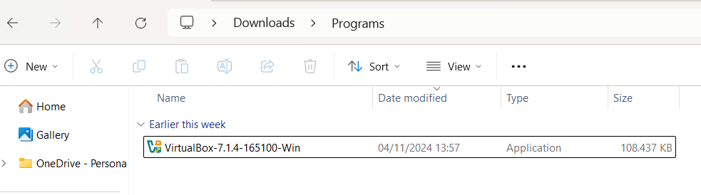

* Then click next to proceed with the installation

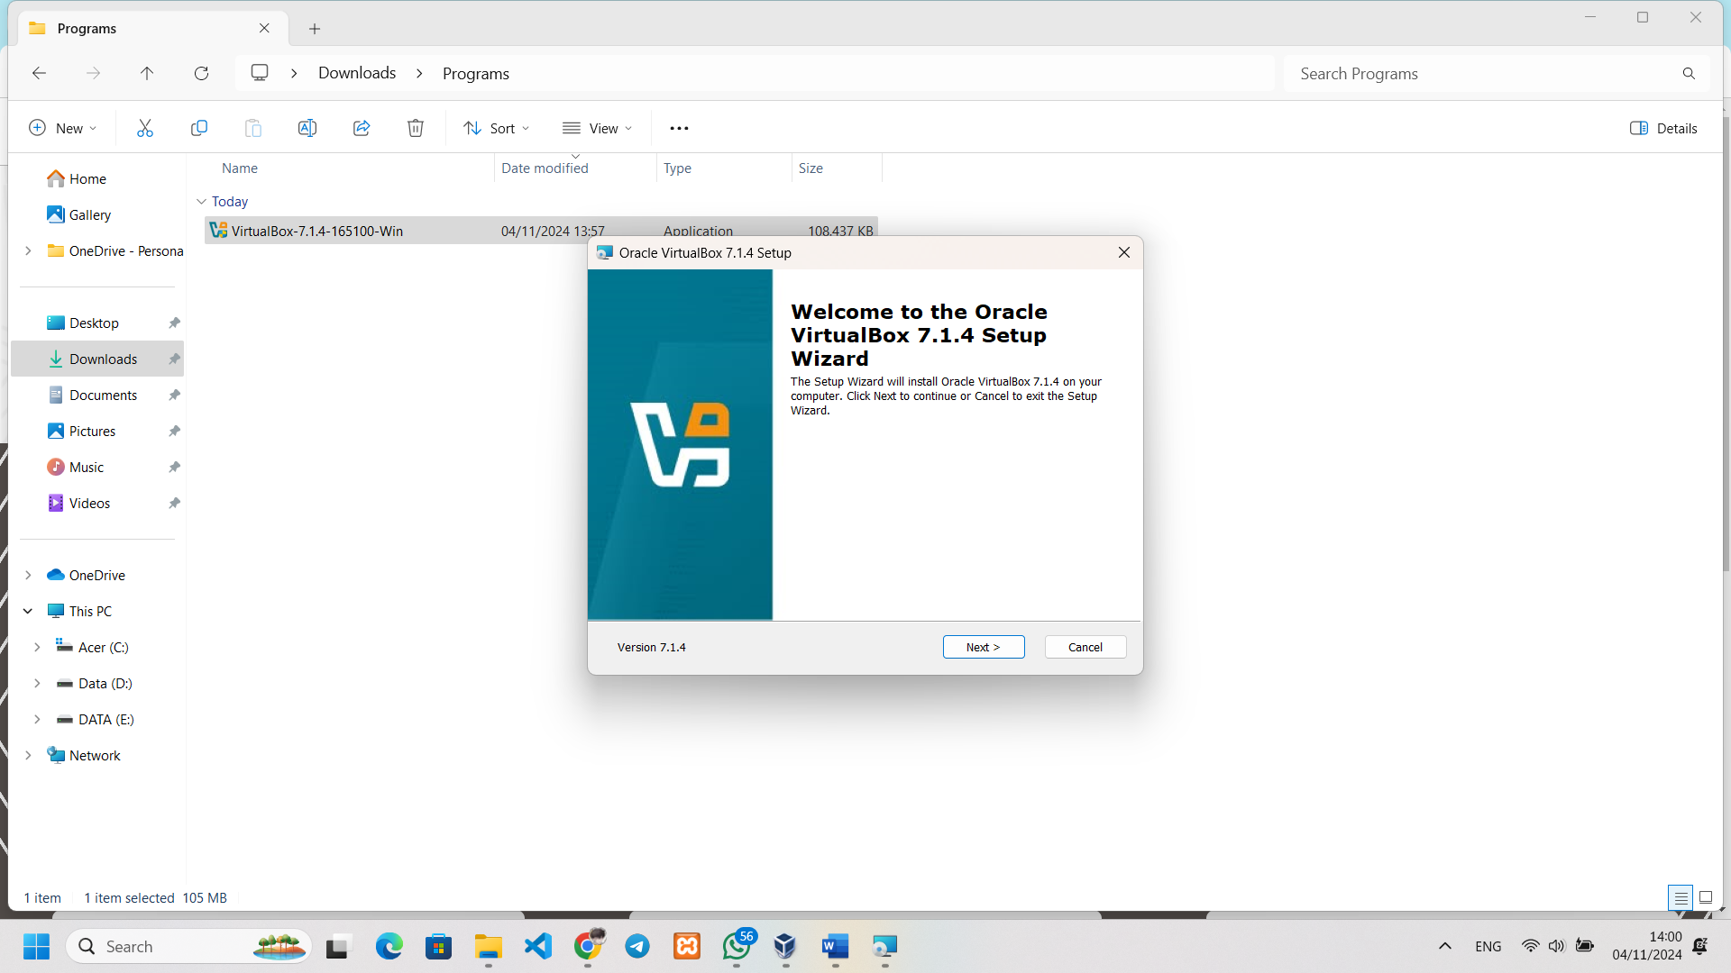

* In the End-User License Agreement section, you are told to read the virtualbox license after you are done, click "I accept the terms in the License Agreement" then click next.

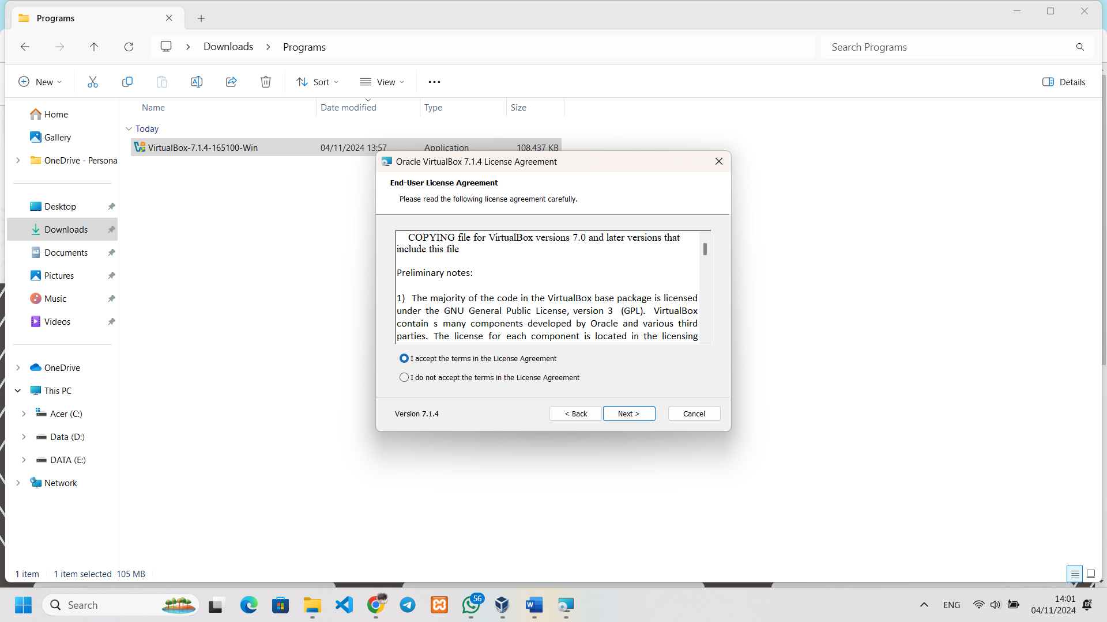

* This section is told to select a storage location from the virtualbox after selecting the storage and then click next.

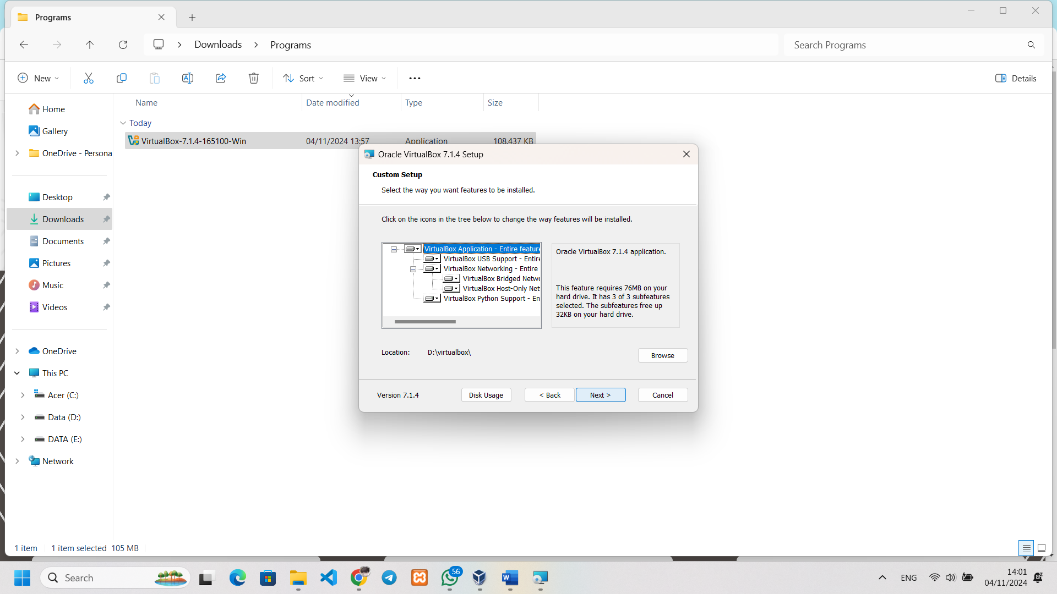

* This section has a warning about the network being temporarily disconnected because virtualbox has to install a new network driver if it doesn't extend the internet network constantly click next.

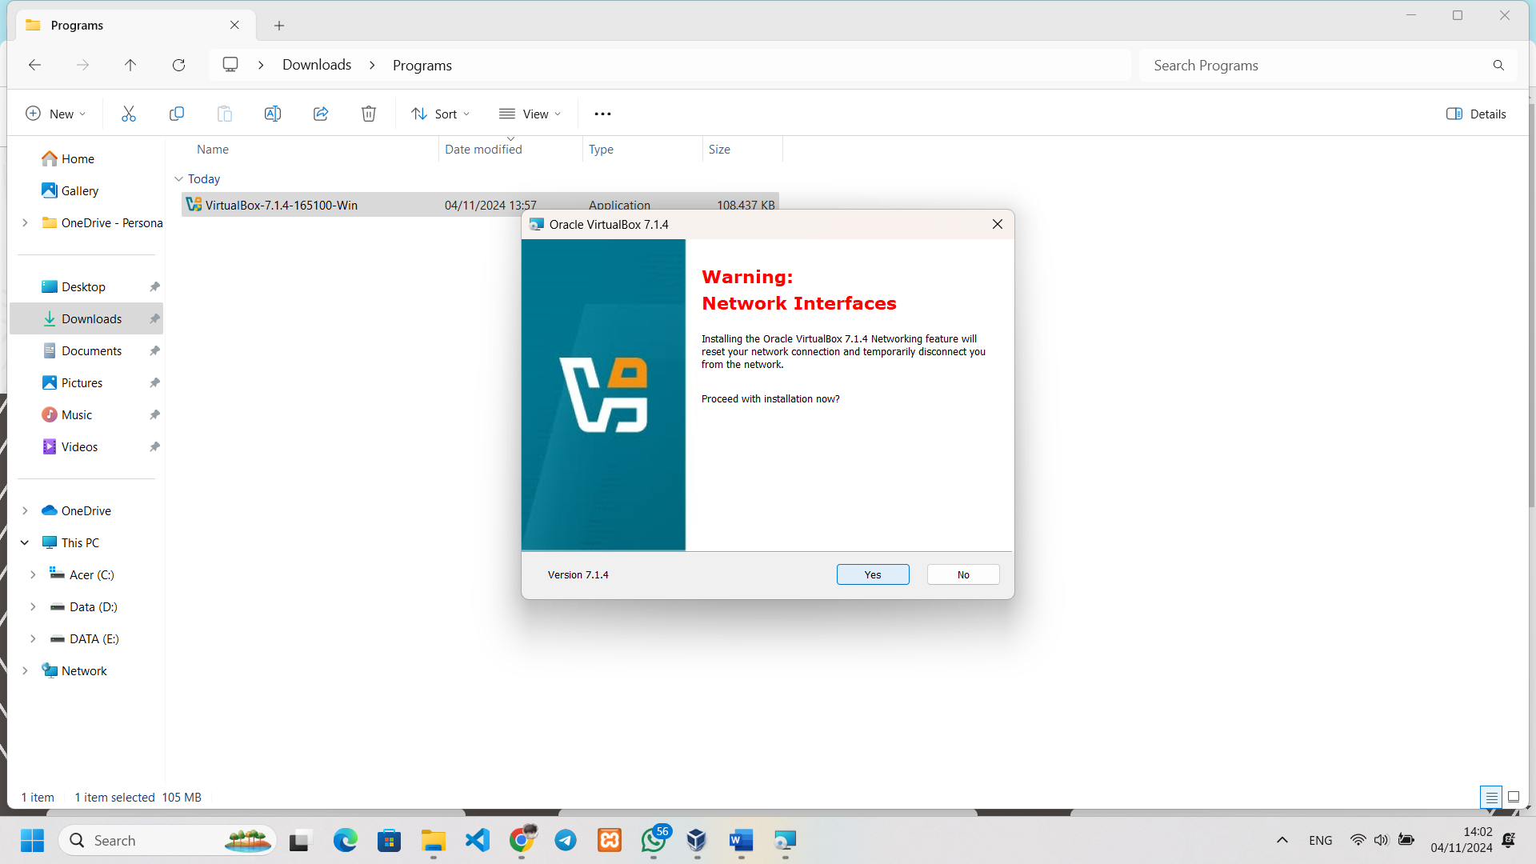

* This confirms whether the computer has installed python core/win32api, for how to check it using python –version. After confirming that it is installed, click Yes.

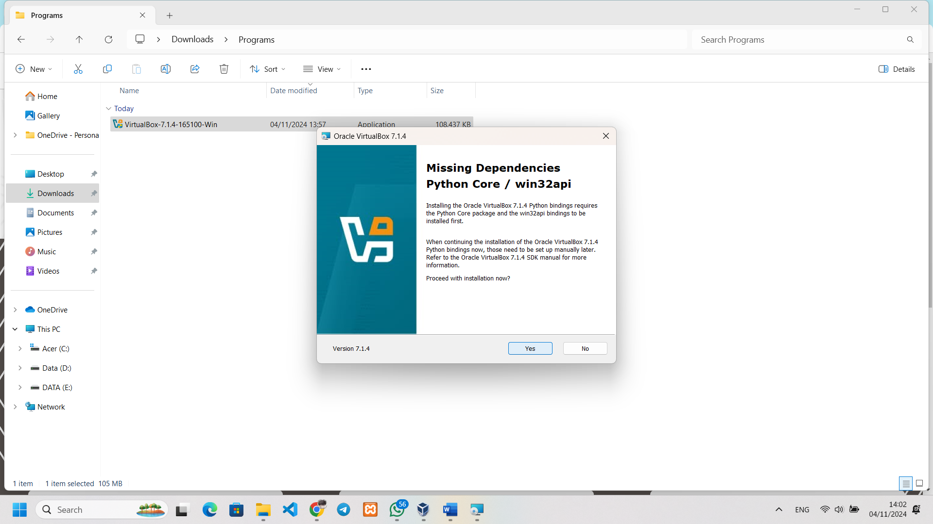

* Here there are several features, for example, the program is directly on the desktop, select one or all of them, then click Yes.

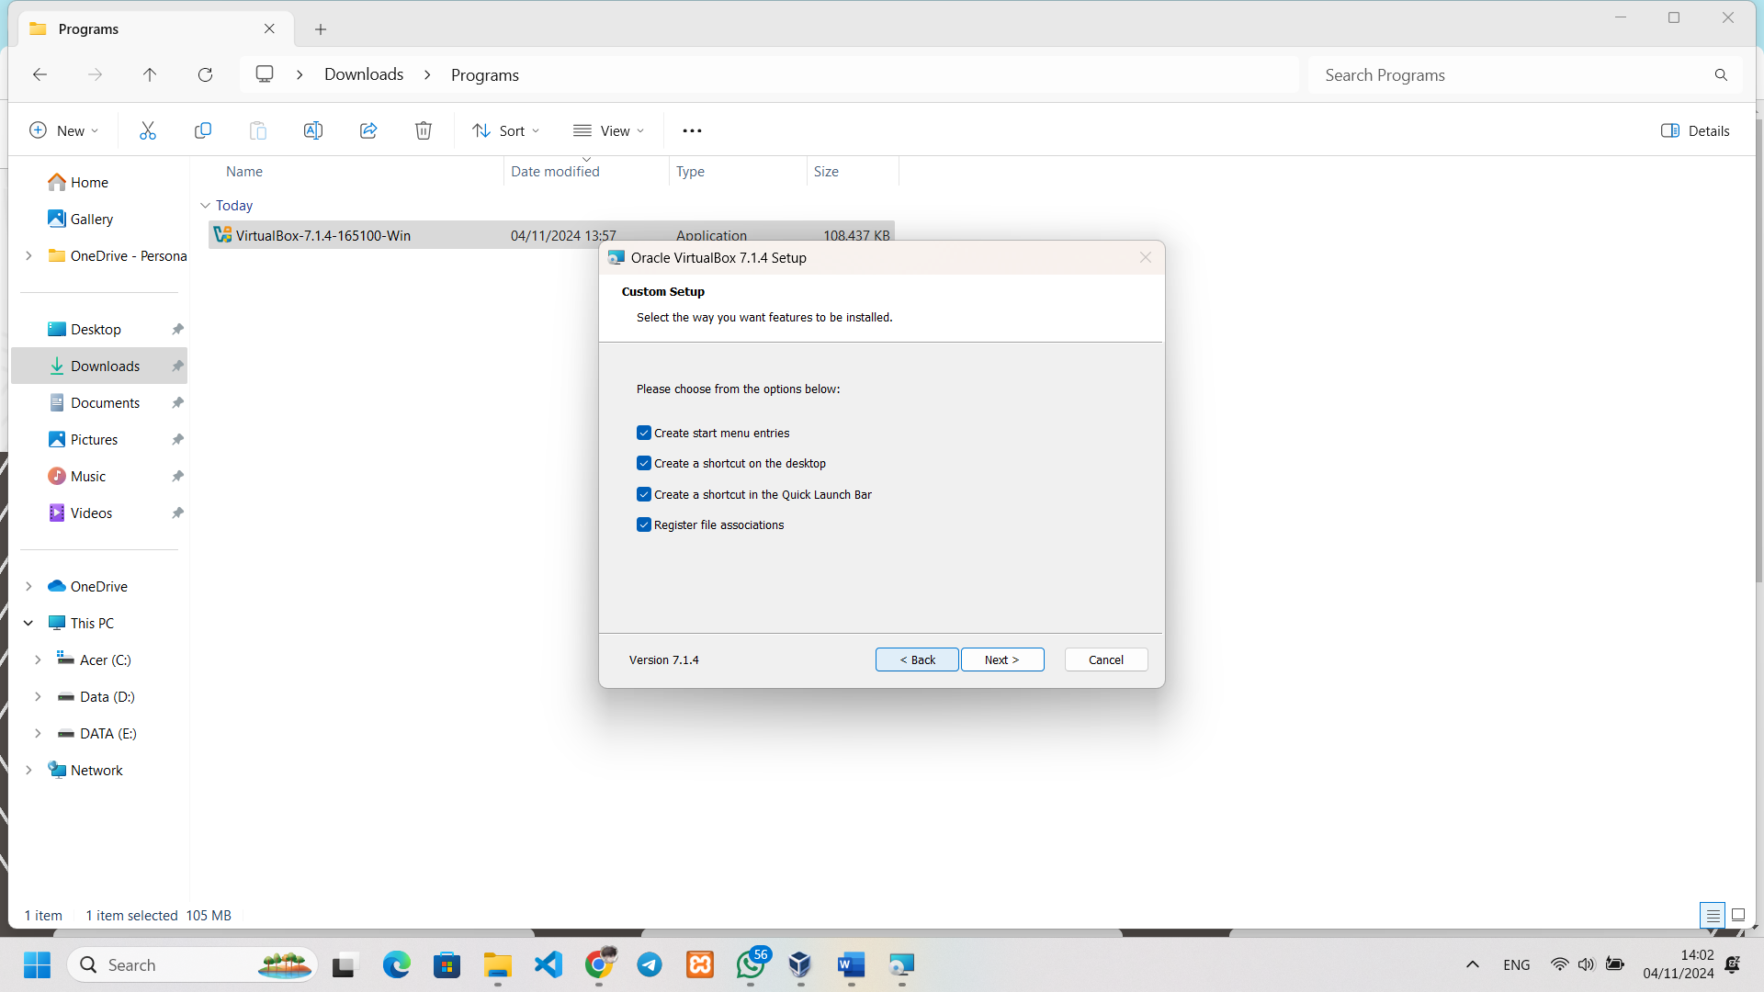

* In this section there is a reminder, for example, there is a setting that you want to change, click back, if it is appropriate, then click install and wait until there is a writing Installation comlete, which means that the installation of the virtualbox is successful.

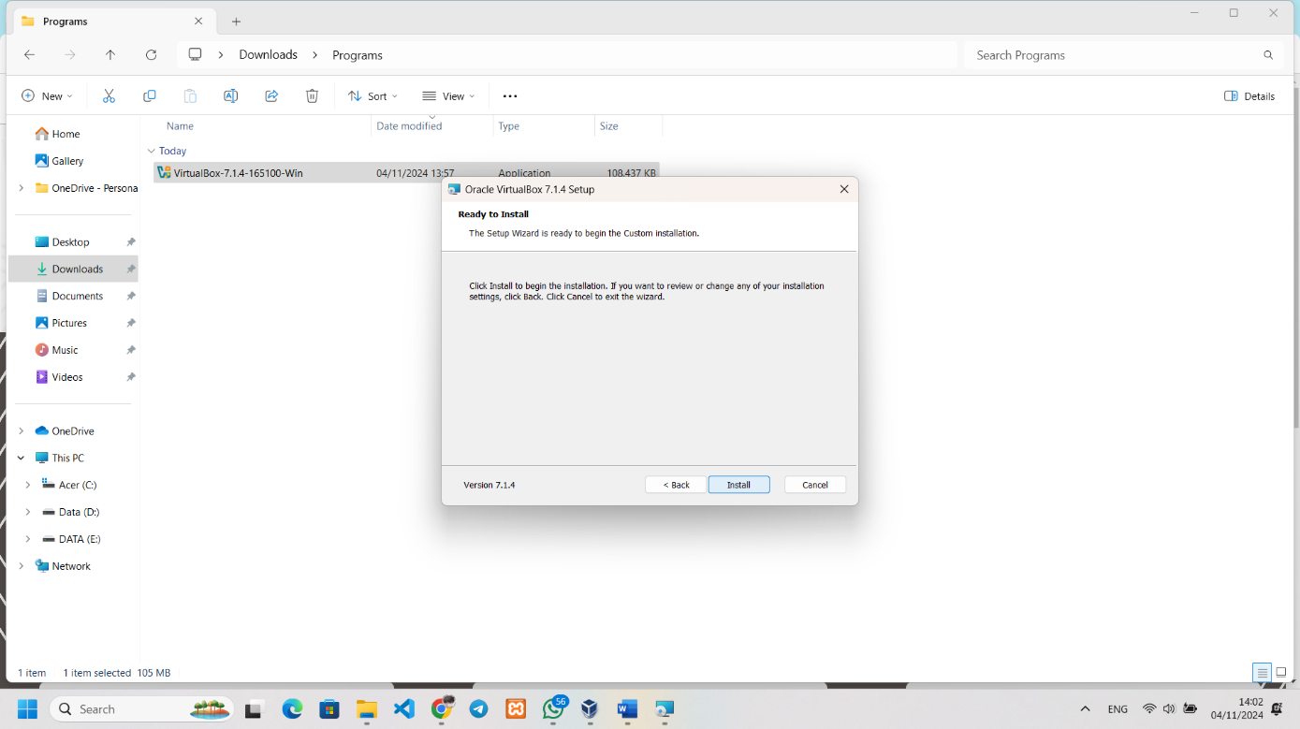

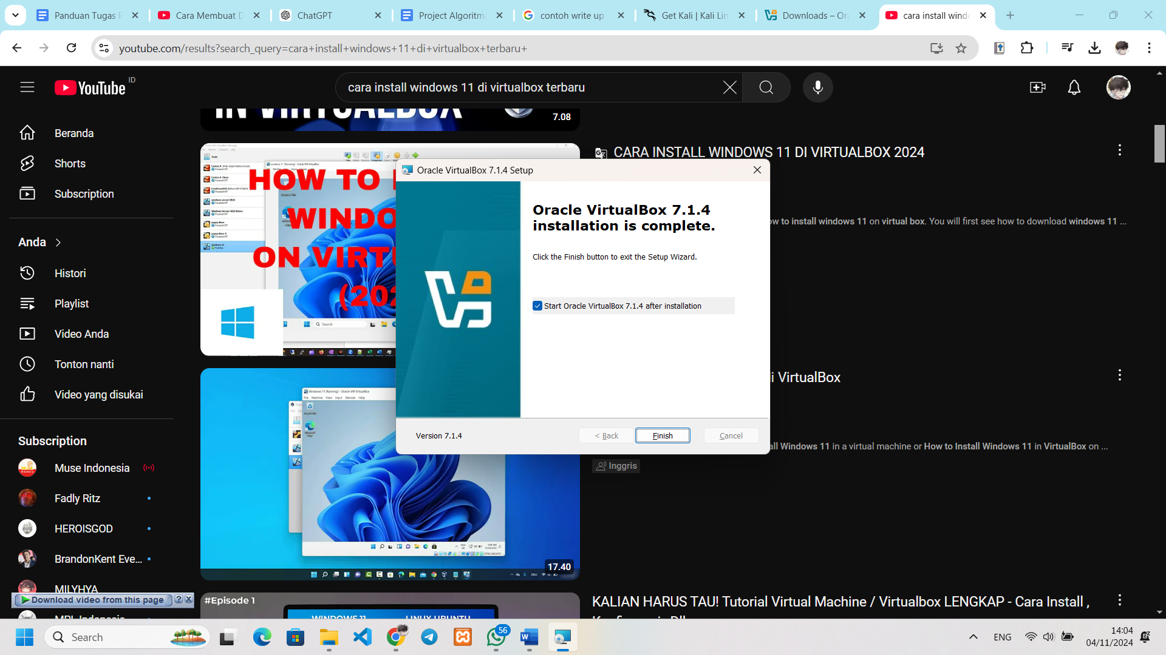

* 1. Ubuntu 20.04 Installation

Before installing Ubuntu Server/Desktop, make sure to download Ubuntu via the following link:

<https://releases.ubuntu.com/focal/>

After downloading ubuntu, we continue to install it:

* Open the virtualbox that has been installed and then click new

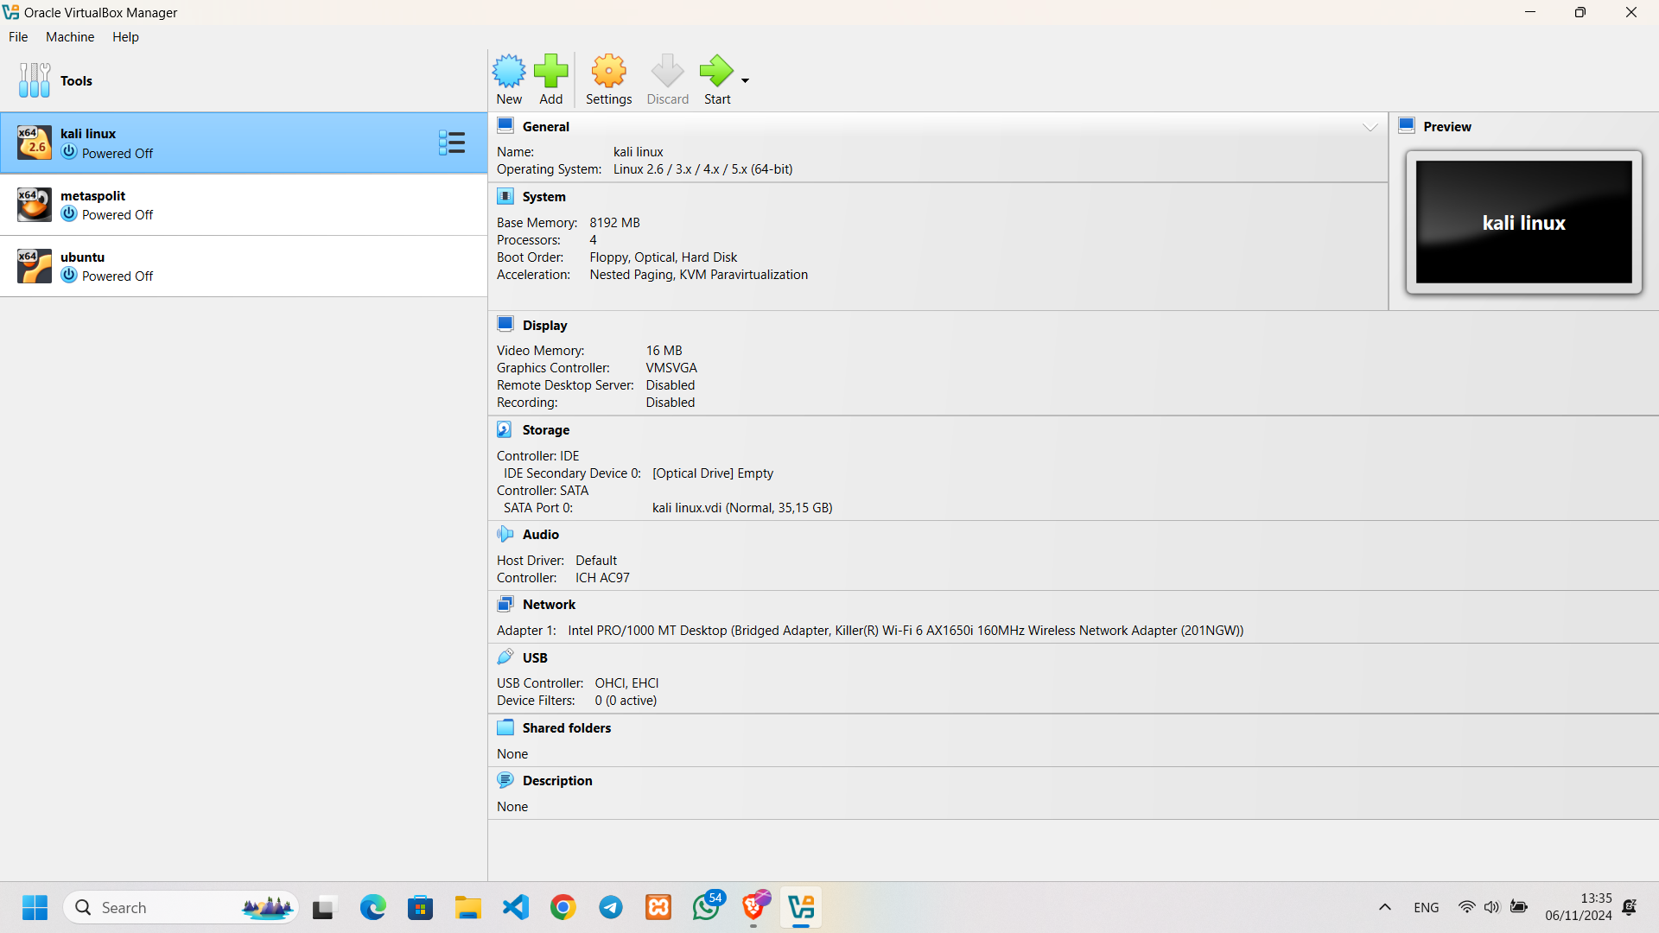

* After clicking new it will appear like the photo below there is a virtual machine naming, a folder to store the virtual machine, enter the ubuntu iso file that has been downloaded

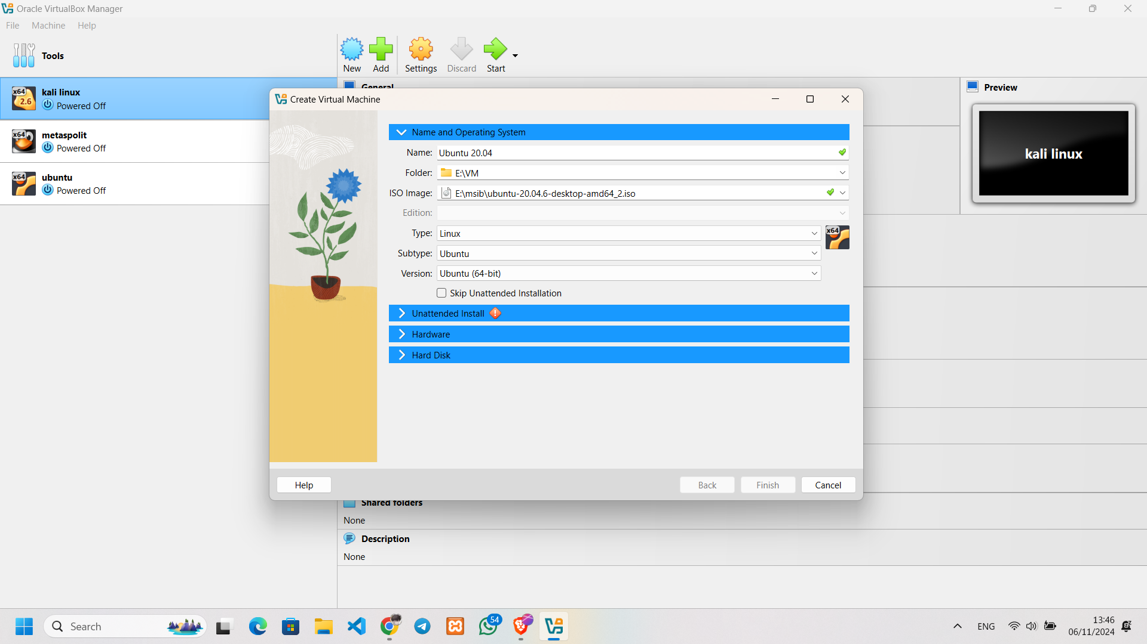

* Click "Unattended Install" this section simplifies automatic installation by only providing username, password and hostname for the latest version of virtualbox, while for the previous version of virtualbox the provision of username, password and hostname is done on manual installation.

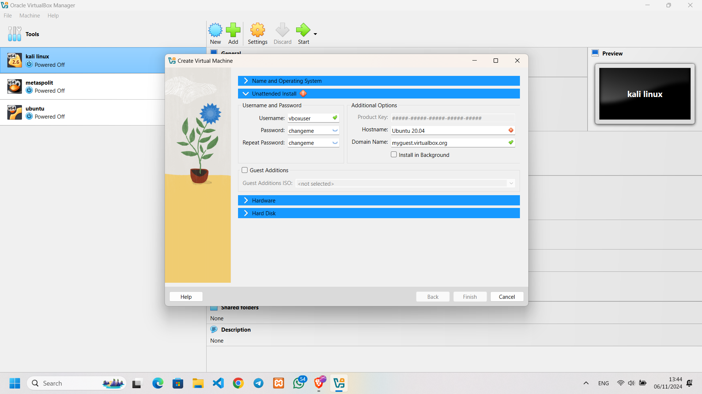

* Click on "Hardware" this section sets the RAM and CPU. Recommended for ubuntu desktop RAM 4/more and CPU 2/more for smoothness.

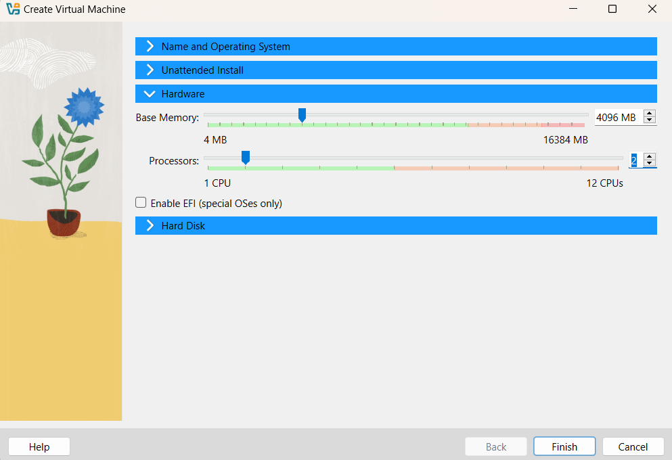

* Click on "Hard Disk" section makes it possible to create a new virtual hard disk for Ubuntu VMs, with some options such as specifying the size, storage location or using an existing virtual disk file. Recommended for ubuntu desktop 20GB or as per the user's requirements. Then click finish

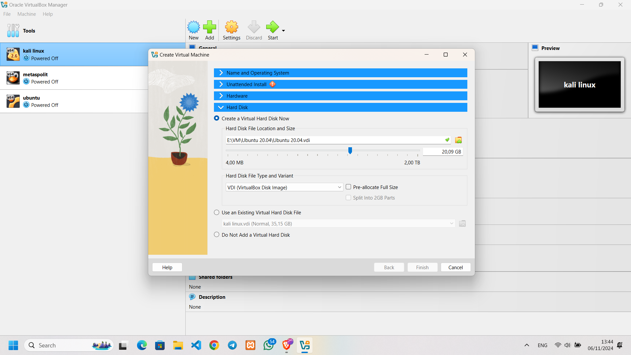

* After that, click start to start the installation

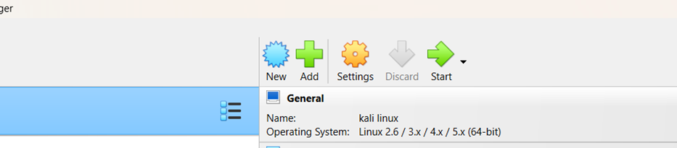

* After that, wait until the installation is complete and reboot

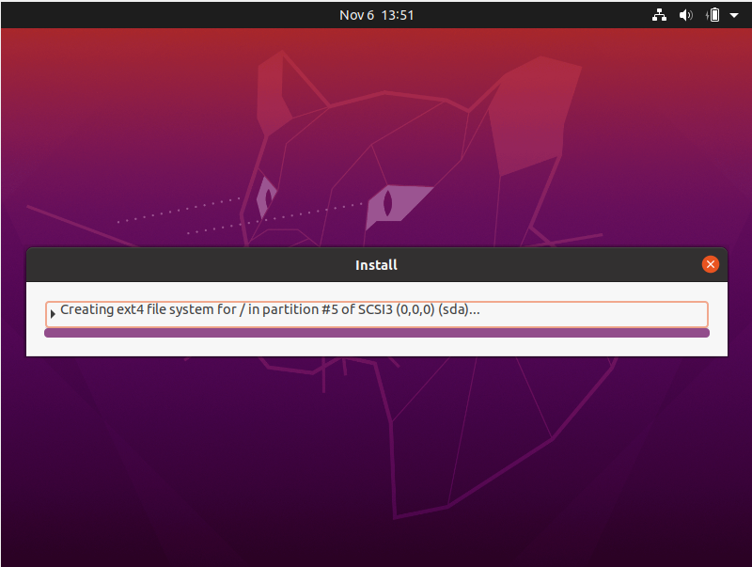

* The reboot is complete, it will appear according to the photo below, click the username, then enter the password and can run the Ubuntu OS.



* 1. Kali Linux Installation

Before installing Ubuntu Server/Desktop, make sure to download Ubuntu via the following link:

<https://www.kali.org/get-kali/#kali-installer-images>

After downloading ubuntu, we continue to install it:

* Open the virtualbox that has been installed and then click new



* After clicking new it will appear like the photo below there is the naming of the virtual machine, the folder to store the virtual machine, enter the file linux.iso the time that has been downloaded.

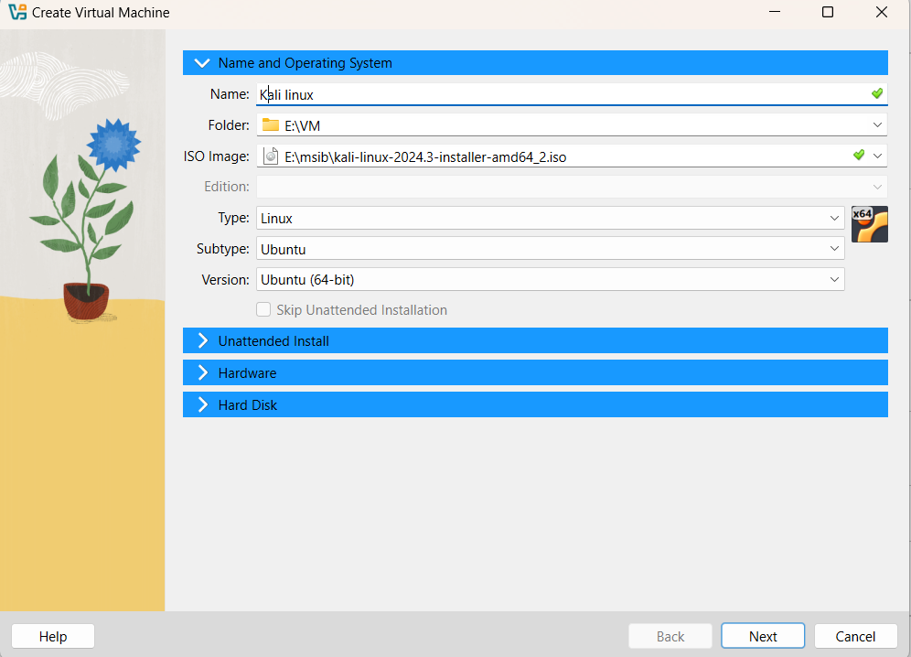

* For times when linux can't do the automatic installation feature, you have to use manual installation.

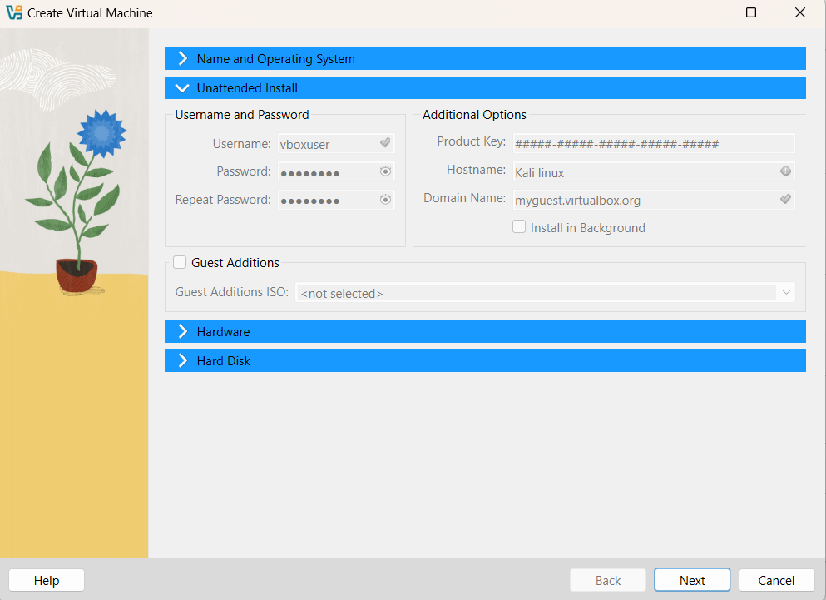

* Click on "Hardware" this section sets the RAM and CPU. Recommended for ubuntu desktop RAM 4/more and CPU 2/more for smoothness.

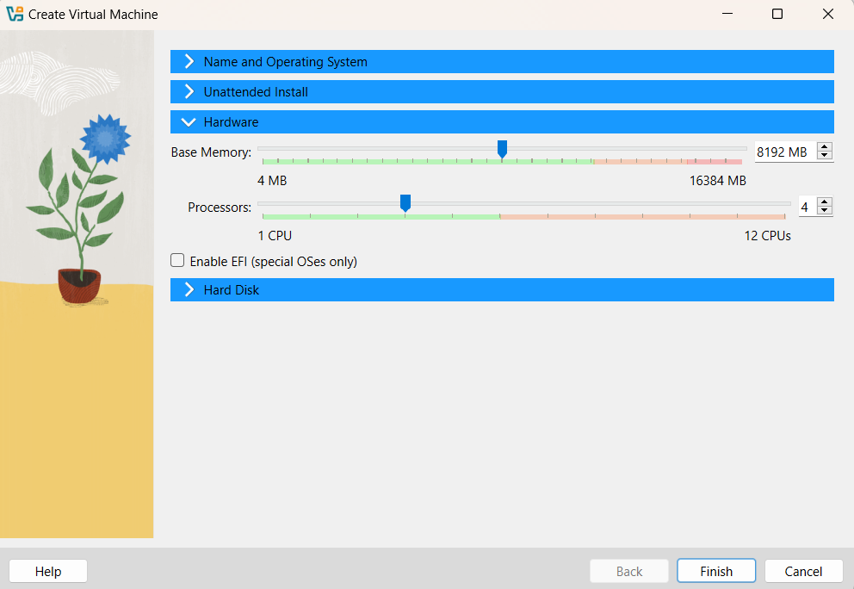

* Click on "Hard Disk" section makes it possible to create a new virtual hard disk for Ubuntu VMs, with some options such as specifying the size, storage location or using an existing virtual disk file. Recommended for ubuntu 40GB desktop to install the necessary tools. Then click finish

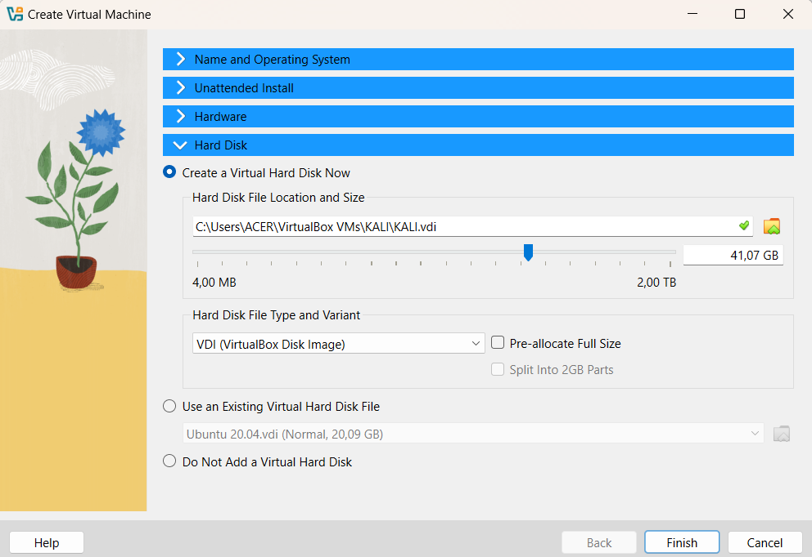

* After that, click start to install linux times.

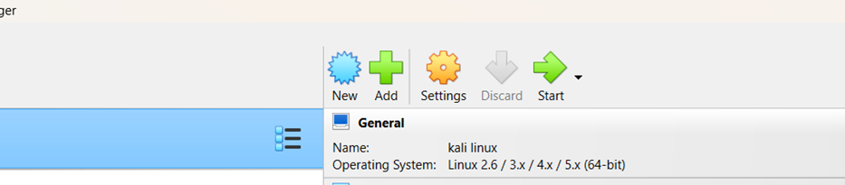

* In this section, select Graphical install to make the installation easier. You can also select the Install section but use the CLI (Command Line Interface).

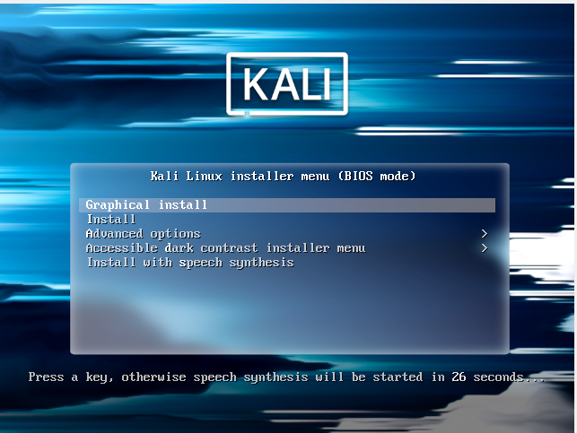

* In this section, select the language to be used then click countinue.

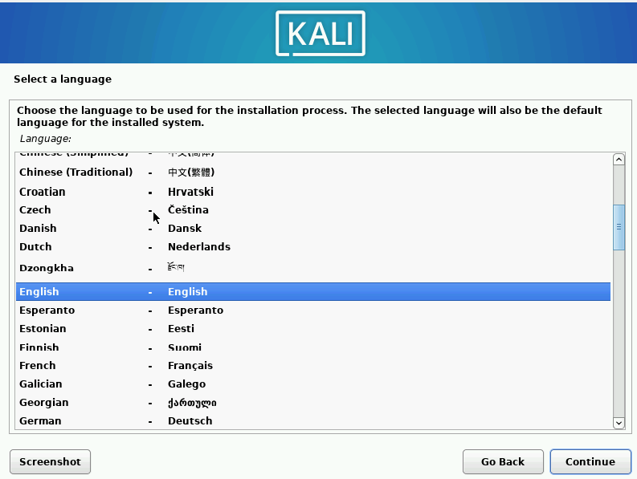

* This section is used to select a location. For Indonesia location, click other>asia>indonesia then click continue

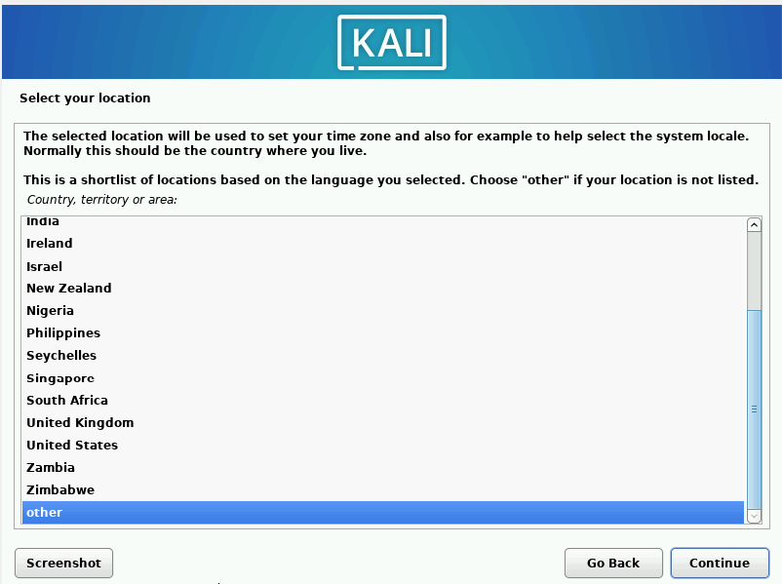

* This section selects the keyboard to be used.

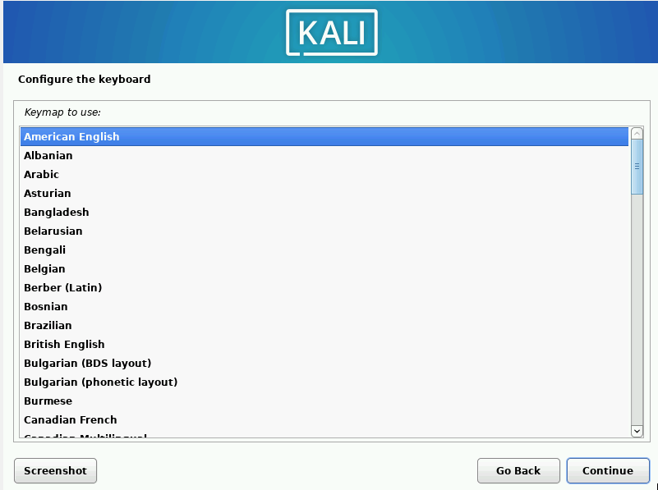

* Give the hostname and domain name to the system then click continue.

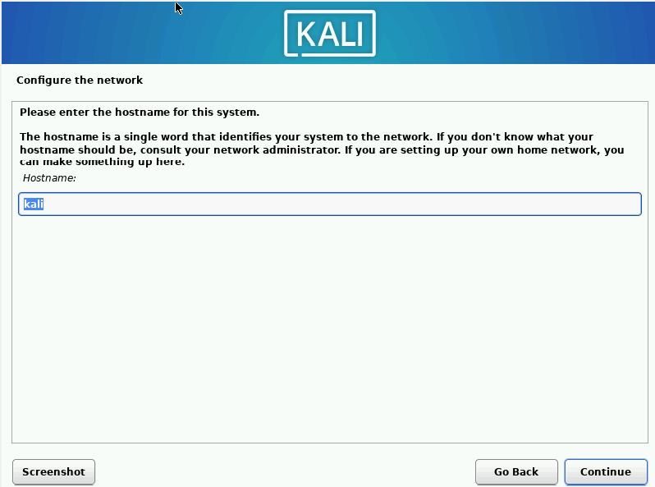

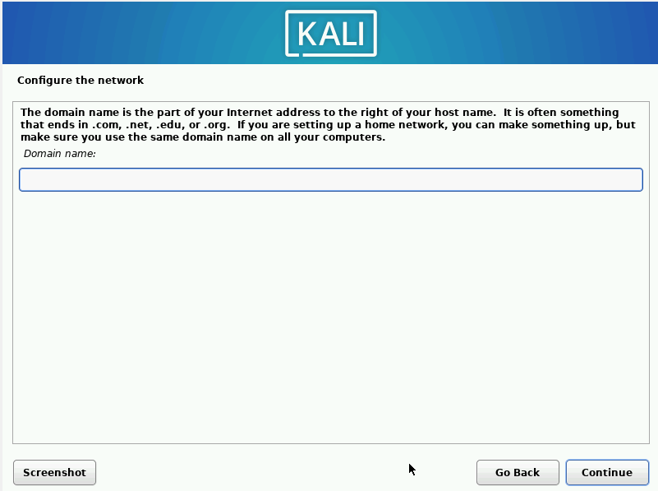

* This section provides username and password

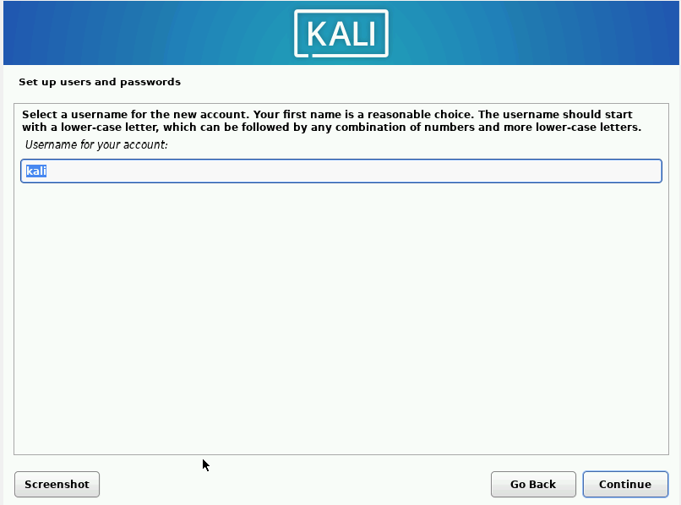

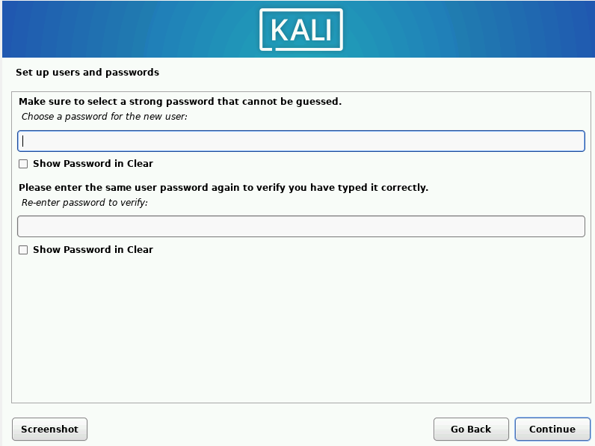

* This section selects the time location.

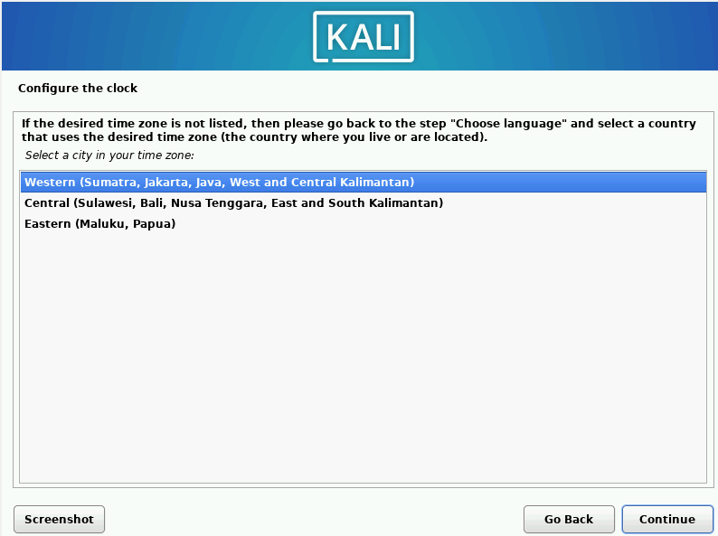

* This section provides several options, from using the entire disk, using LVM (Logical Volume Management), to setting up an encrypted LVM, or choosing a manual partition for full control over disk settings. I recommend using the entire disk so that the system automatically chooses itself.

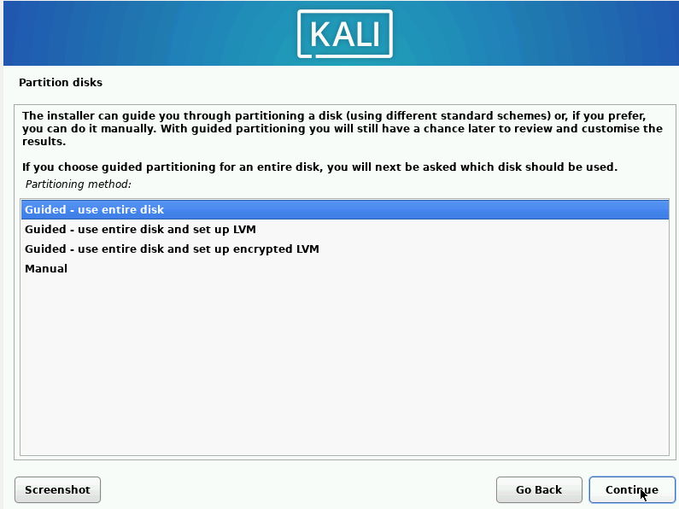

* Select the software/tools to be installed. These tools are the most frequently used tools in the river.

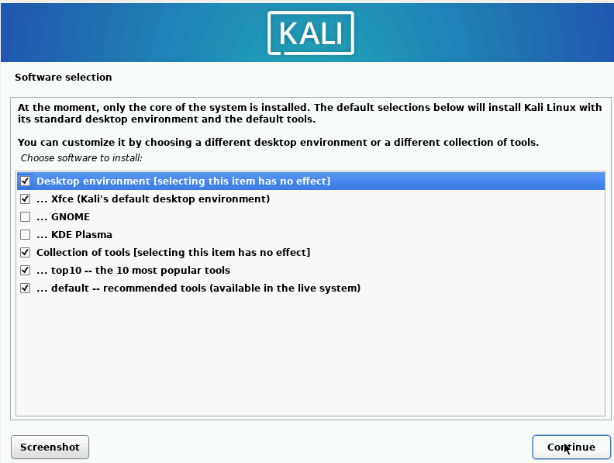

* After everything is done, the system will ask for a reboot and the time linux can be used.

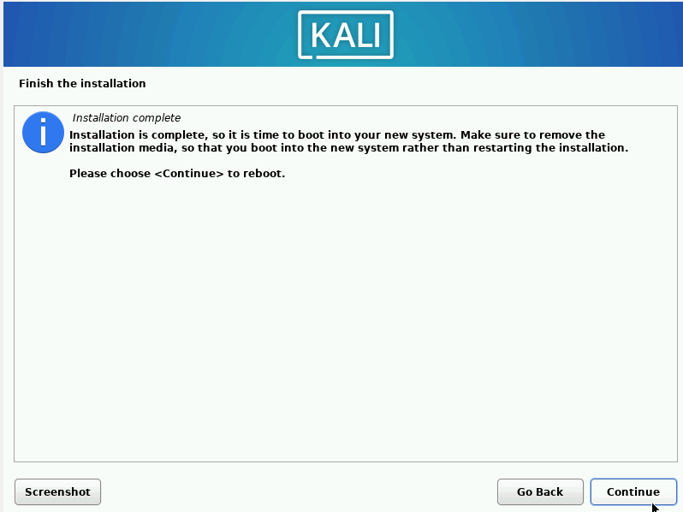

# **Chapter 3 Ubuntu and Kali Addres IP Configuration**

3.1 Ubuntu Addres IP Configuration

* Before proceeding, we need to change the network settings in VirtualBox. Select the virtual machine you want to change, then click "Settings" > "Network". In the "Attached to" section, change the option that previously said "NAT" to "Bridged Adapter." By using the Bridged Adapter, the virtual machine will connect directly to the host's physical network, so the VM will get the same IP address as other devices on the local network.



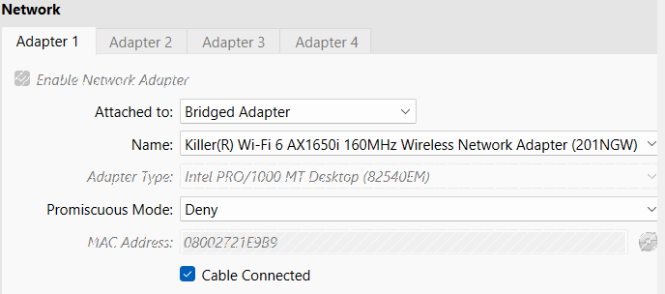

3.1.1 Configuration via network manager,

* Open the terminal first to know the IP address before configuring it and the netmask. To open the terminal, you can use the shortcut Ctrl + Alt + T or search for it in the menu. After that, type ip a will appear as below. It is seen that the ip before configuration is 192.168.0.31 with netmask 24.

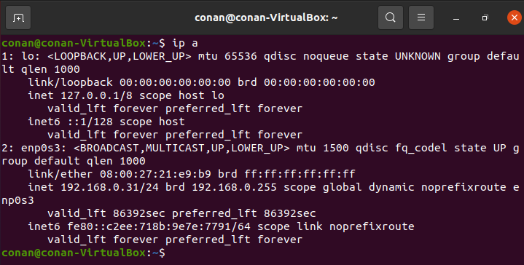

* After knowing the netmask, then click like dot 3 in the upper right corner, it will appear as shown below, then click wired settings.

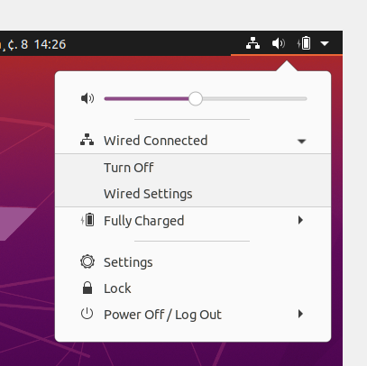

* After clicking, it will appear as below, then click the settings icon in the right corner of the image

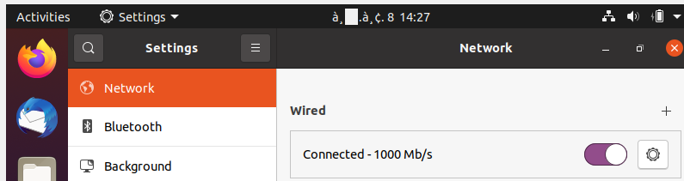

* After a display like this, then click on the IPv4 text and notice here you can see the gateway, which is 192.168.0.101

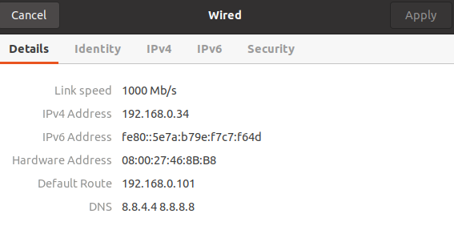

* Then click on the manual whose initial setting is automatic (DHCP), then enter the IP Address, for example 192.168.0.99, then the netmask already exists, namely 24 = 255.255.255.0 and enter the gateway 192.168.0.101. Then finally click Apply.

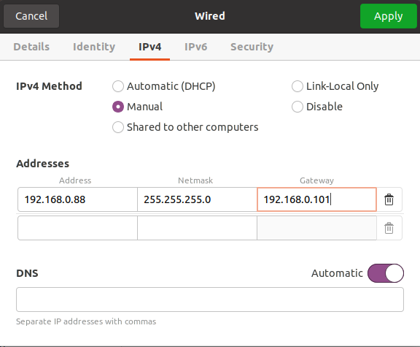

* Open the terminal, check the IP address with ip a, then check the connection to Google's DNS with the ping command 8.8.8.8, and make sure the IP has changed and the ping is successful.

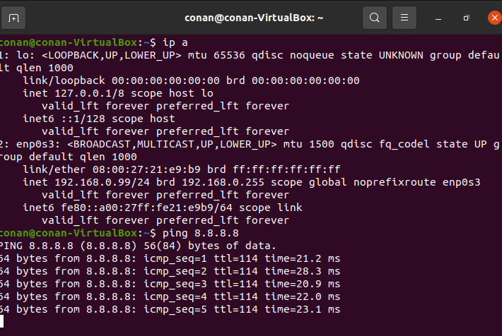

3.1.2 Configuration via terminal.

* Open the terminal first to know the IP address before configuring it and the netmask. To open the terminal, you can use the shortcut Ctrl + Alt + T or search for it in the menu. After that, type ip a will appear as below. It is seen that the ip before configuration is 192.168.0.31 with netmask 24.



* Then type the sudo nano /etc/netplan/01-network-manager-all.yaml command in the terminal and it will appear as an empty width.



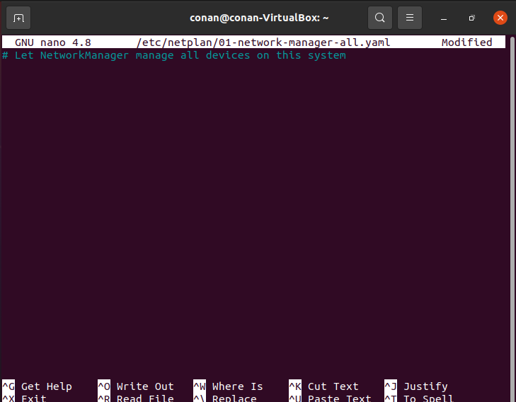

* Then enter the following text and save using Ctrl + O, 192.168.0.99 is the ip address /24 is the netmask and 192.168.0.101 is the gateway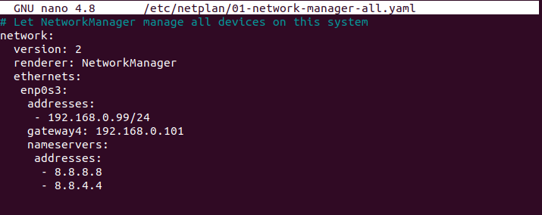
* After saving, type the sudo netplan apply command on the terminal. sudo netplan apply is used to apply the network configuration that has been changed through the Netplan configuration file.



* Type the IP address with ip a again , then check the connection to Google's DNS with the ping command 8.8.8.8, and make sure the IP has changed and the ping is successful.



* Once the configuration is complete, the IP address has been successfully applied as desired, and the internet connection is tested with a successful ping to Google's DNS, which indicates that the network is working properly.

3.2 Configuration of IP Addres Kali Linux

* Before proceeding, we need to change the network settings in VirtualBox. Select the virtual machine you want to change, then click "Settings" > "Network". In the "Attached to" section, change the option that previously said "NAT" to "Bridged Adapter." By using the Bridged Adapter, the virtual machine will connect directly to the host's physical network, so the VM will get the same IP address as other devices on the local network.





3.2.1 Configuration via network manager,

* Open the terminal first to know the IP address before configuration, Netmasik and Gateway. To open the terminal, you can use the shortcut Ctrl + Alt + T or search for it in the menu. After that, type ip a will appear as below. It is seen that the ip before configuration is 192.168.0.31 with netmask 24. And to view the Gateway uses ip route | grep default which is 192.168.0.101.

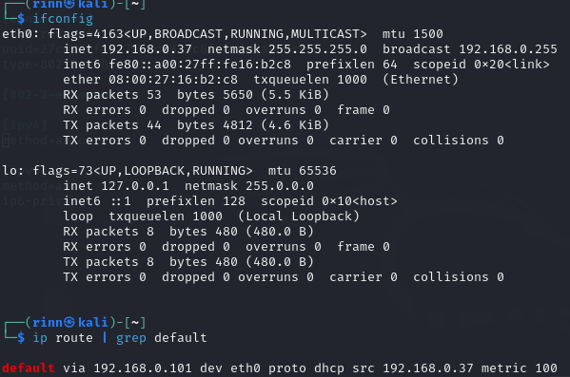

* Click on the left corner with the picture of linux then look for Advanced Network Configuration then click on the program.

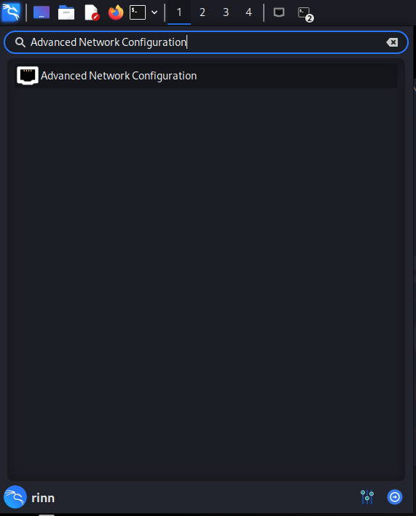

* Later it will appear as shown in the image below, then click 2 times Wired connection 1.

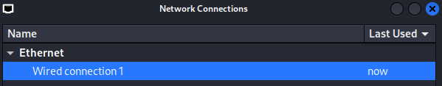

* Click IPv4 Settings.

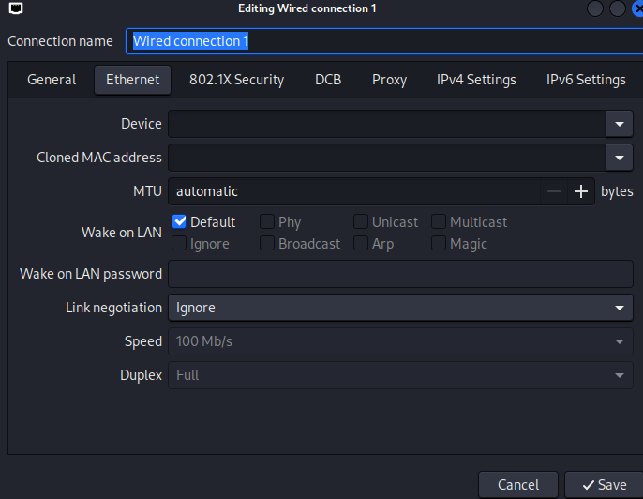

* Then enter the ip address, netmask, gateway and DNS which are configured after entering everything click save.

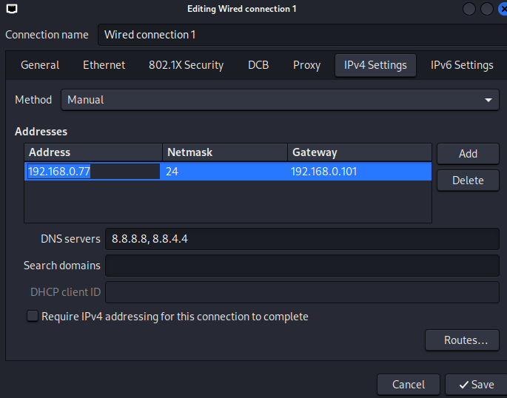

* Type the command on the terminal sudo systemctl restart NetworkManager to update and apply the new network configuration on Kali Linux.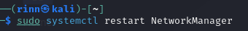
* Type the IP address with ip a again , then check the connection to Google's DNS with the ping command 8.8.8.8, and make sure the IP has changed and the ping is successful.

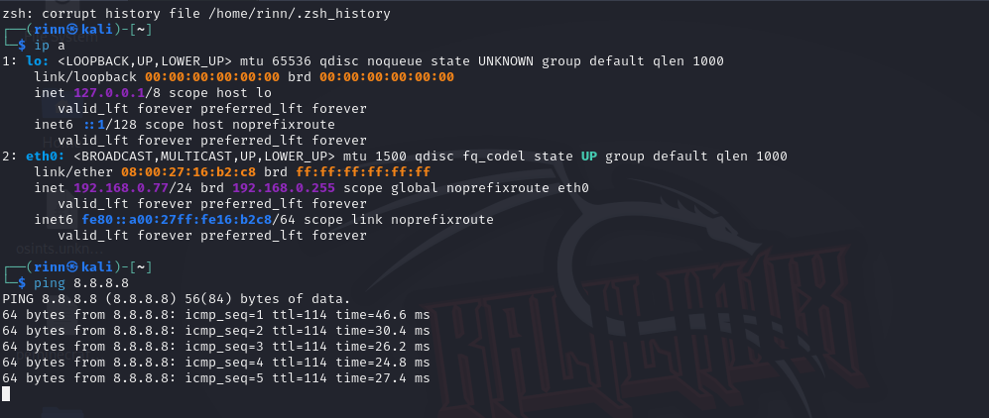

3.2.2 Configuration via terminal.

* Open the terminal first to know the IP address before configuration, Netmasik and Gateway. To open the terminal, you can use the shortcut Ctrl + Alt + T or search for it in the menu. After that, type ip a will appear as below. It is seen that the ip before configuration is 192.168.0.31 with netmask 24. And to see the Gateway using ip route | The default grep is 192.168.0.101.

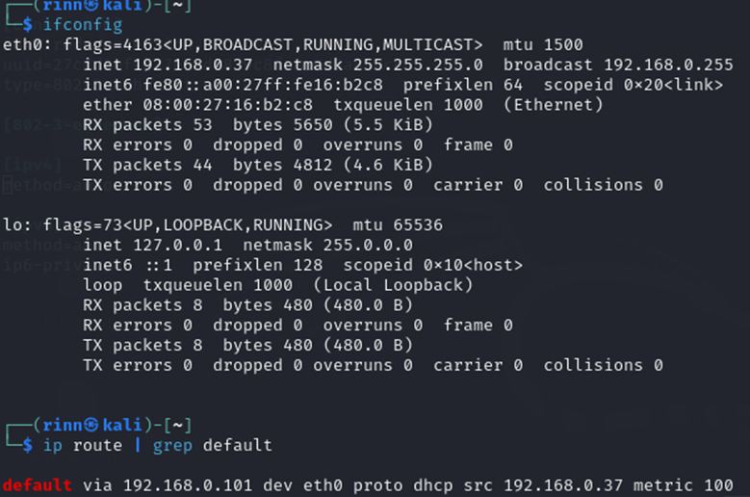

* after that type the sudo nano command /etc/NetworkManager/system-connections/'Wired connection 1' to edit the 'Wired connection 1' file.



* Later it will appear as shown in the image below and then change the [IPv4] part to

method=manual

addresses=192.168.0.77/24

gateway=192.168.0.101

dns=8.8.8.8; 8.8.4.4

don't forget to save the file with Ctrl+O.

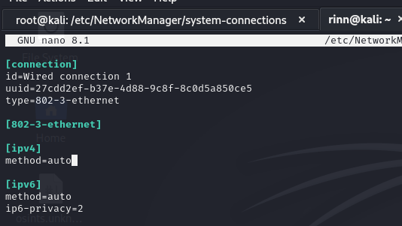

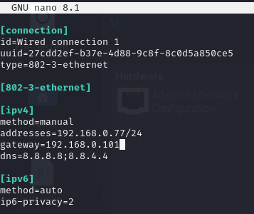

* Type in the terminal command sudo systemctl restart NetworkManager to update and apply the new network configuration on Kali Linux.
* Type the IP address with ip a again , then check the connection to Google's DNS with the ping command 8.8.8.8, and make sure the IP has changed and the ping is successful.



Conclusion

that both Kali Linux and Ubuntu use NetworkManager for network configuration, which can be done through the GUI or terminal. On both systems, IP, gateway, and DNS configurations can be applied without a reboot, just by running the appropriate commands such as sudo systemctl restart NetworkManager on Kali Linux or sudo netplan apply on Ubuntu.

# **Chapter 4 Installing SSH, Mysql, Apache, and PHP on Ubuntu**

Before doing the "sudo apt update" this is used to update the list of packages that are in the repository. And this "sudo apt upgrade" is used to update all installed packages to the latest version available in the repository list.

4.1 **SSH Installation**

* For SSH installation on Ubuntu or sometimes you can use the command: "sudo apt install openssh-server" because both are debian-based, this is for example on ubuntu.

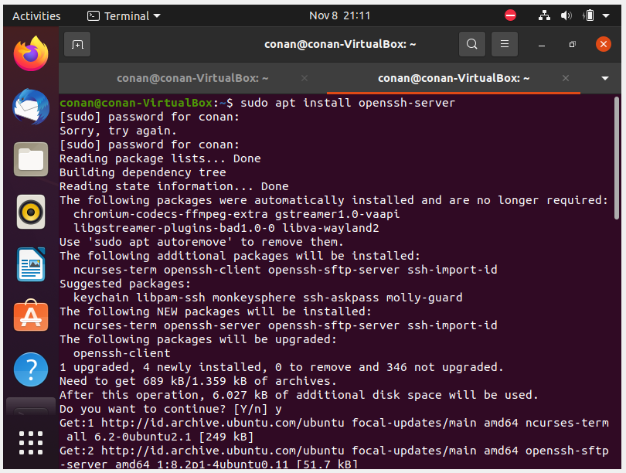

* And to check if SSH is running using the command: "sudo systemctl status ssh" and to turn on SSH by using the command: "sudo systemctl start ssh"

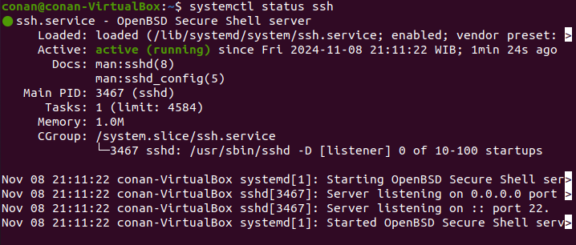

4.2 MYSQL Installation

* For Mysql installation on Ubuntu or sometimes you can use the command: "sudo apt install mysql-server -y" because both are debian-based, this is for example on ubuntu.

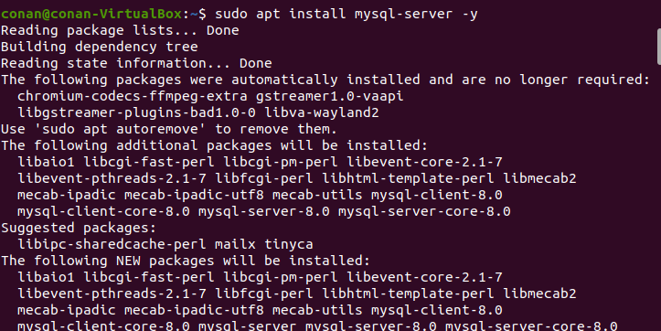

* And to check if mysql is running using the command: "sudo systemctl status mysql" and disable/shut down using the command: "sudo systemctl start mysql"/"sudo systemctl stop mysql".

4.3. Apache Installation

* For Apache installation on Ubuntu or sometimes you can use the command: "sudo apt install apache2" because both are debian-based, this is for example on ubuntu.

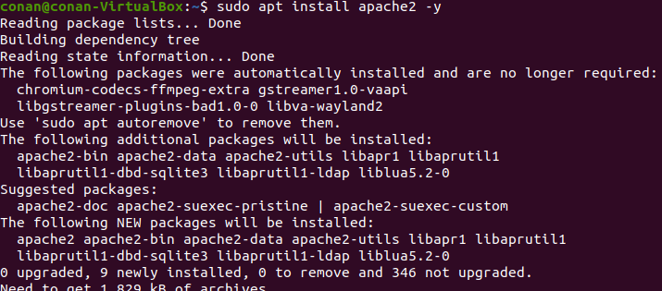

* And to check if Apace is running using the command: "sudo systemctl status apahe2" and disable using: "sudo systemctl start mysql"/"sudo systemctl stop apache2".

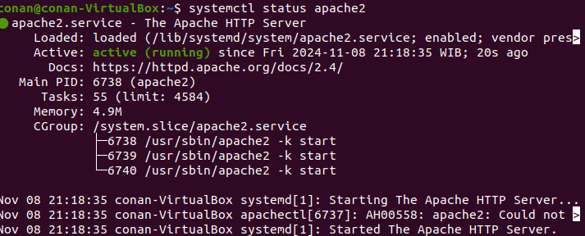

4.4. PHP Installation

* For SSH installation on Ubuntu or sometimes you can use the command: "sudo apt install php libapache2-mod-php" because both are debian-based, this is for example on ubuntu. PHP is enabled with Apache automatically through mod_php modules.

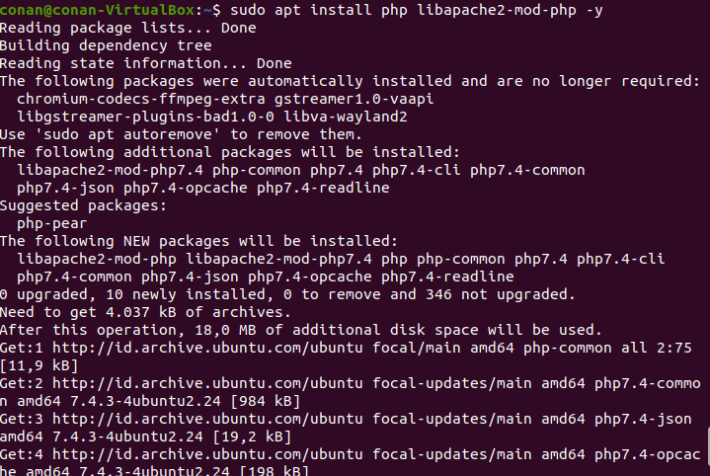

# **Chapter 5 Installation of Webbutler v3.2 on ubuntu**

* 1. Download Webutler v3.2

Before installing Webuttler, make sure to download Webuttler via the following link:

<http://webutler.de/download/webutler_v3.2.zip> Or you can also use the command on the terminal "wget <http://webutler.de/download/webutler_v3.2.zip>"

After downloading virtualbox, we continue to install:

* 1. **Webuttler v3.2 Installation**
* After squeezing the webuttler, it is then unzipped with the command: "unzip webuttler_v3.2.zip".

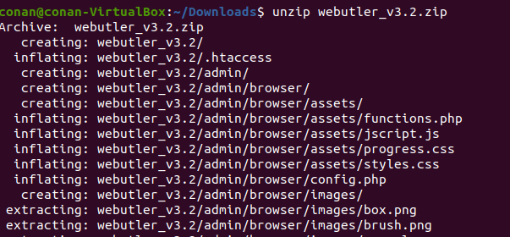

* In order for php to work SQLite, then install it with the command: "sudo apt install php-sqlite3".

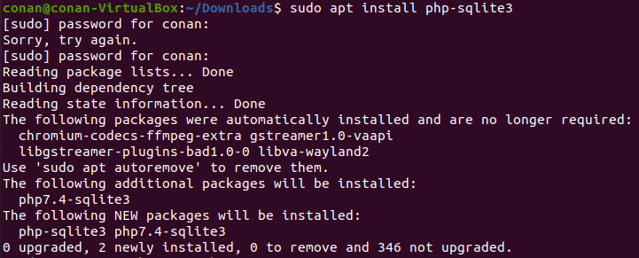

* Copy the webuttler folder to /var/www/html by using the command: "sudo cp -r webutler_v3.2 /var/www/html/".



* To give Apahace access to manage the webuttler folder with the command : sudo chown -R www-data:www-data /var/www/html/webutler_v3.2/
  + chown: Change the ownership of a file or directory.
  + -R: Recursive option, meaning this command will apply to all files and subdirectories within the /var/www/html/webutler_v3.2/ directory.
  + www-data:www-data: Sets the file/directory owner to www-data (default user and group for Apache web servers in many Linux distributions).
  + /var/www/html/webutler_v3.2/: Direktori target.

Then also command: sudo chmod -R 755 /var/www/html/webutler_v3.2/

* + chmod: Changes the permissions of a file or directory.
  + -R: Recursive option, applying changes to all files and subdirectories inside /var/www/html/webutler_v3.2/.
  + 755: Permissions set for files and directories. The number 755 means:
    - 7 (rwx): The owner (user) has read, write, and execute permissions.
    - 5 (r-x): The group has read and run permissions, but can't write.
    - 5 (r-x): Others (public) have permission to read and run, but cannot write.
  + /var/www/html/webutler_v3.2/: Directorate target ,

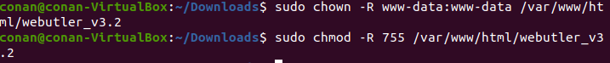

* To run the command that has been changed by using the command: sudo systemctl restart apache2.



* After that, type it in the browser http://<ip your address>/webutller_v3.2/admin/install.php. Later it will appear as shown below. After that, select the language to be used and then click weiter/next.

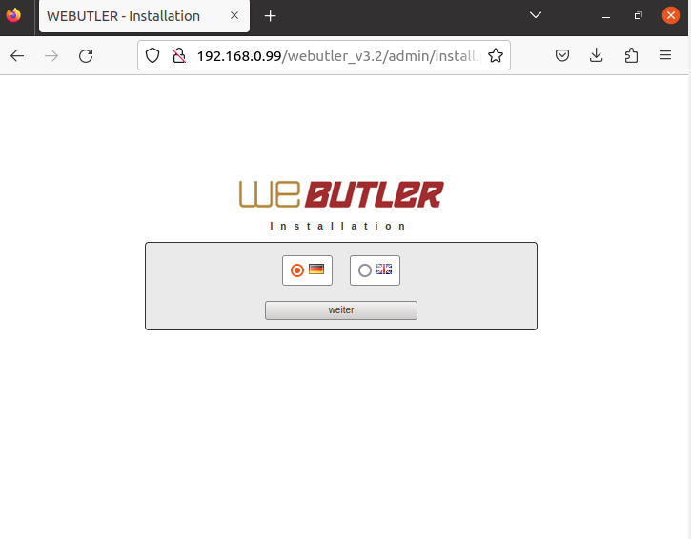

* Later an error will appear as in the image below to solve it do the command: sudo a2enmod rewrite don't forget to also do sudo systemctl restart apache2.

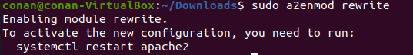

* Then open the 000-default.conf file located in /etc/apache2/sites-available/ with the command: sudo nano /etc/apache2/sites-available/000-default.conf. and add some condiguation as shown below. Don't forget to also sudo systemctl restart apache2 after the file is saved.

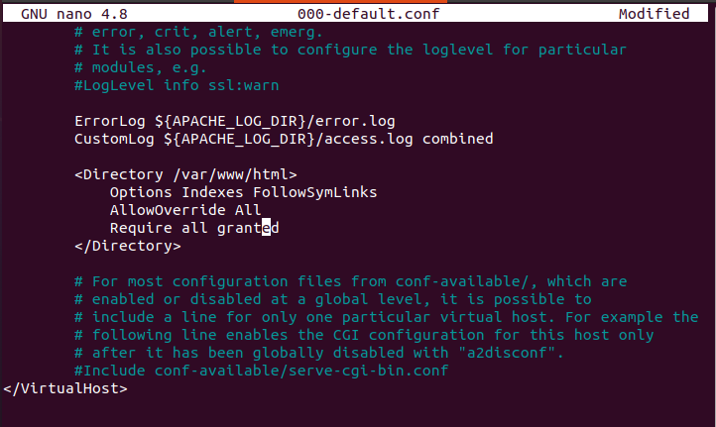

* Restart the browser later and an error will appear again as below. It tells you to give salt keys to globalvars.php file to do so using the command: sudo nano /var/www/html/webutler_v3.2/settings/globalvars.php.

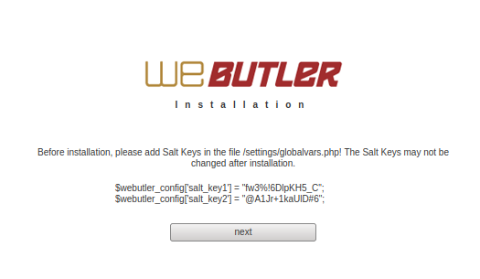

* Then enter the salt keys found in the browser. After that click next

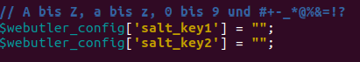

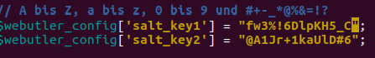

* Enter your username and password. Here it is up to you to use what username or password. After that, click save settings.

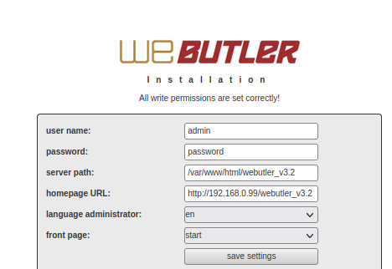

* After that, click go to login.

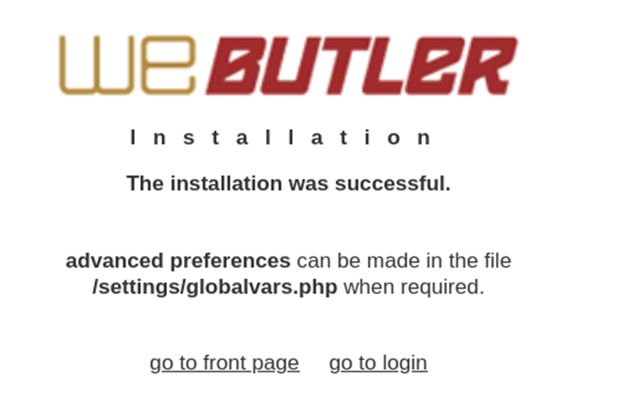

* If the front page is empty, enable the error display in PHP by editing the php.ini file by doing the command: sudo nano /etc/php/7.4/apache2/php.ini.



Later look for the configuration as shown in the photo below







To speed up the search, you can use Ctrl + W. don't forget to also sudo systemctl restart apache2.

* Restart the browser later and an error will appear as shown below. This has to do with DOMDokument how to solve it with the command: sudo apt-get install php-xml.

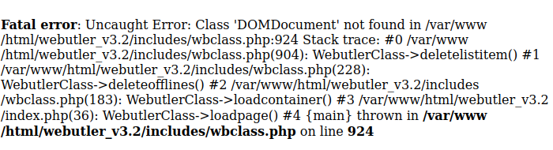

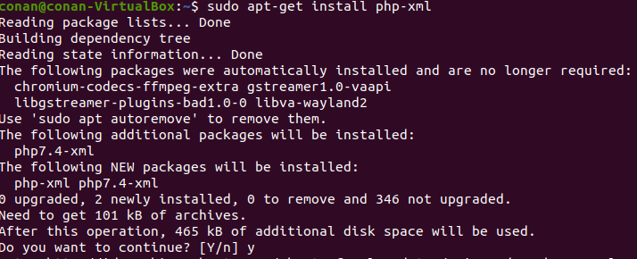

* Don't forget to also sudo systemctl restart apache2. Then restart the browser.



# **Chapter 6 Analyzing Ubuntu server security**

6.1. Network Scanning using Nmap

Nmap (Network Mapper) is an open-source tool used to scan networks and systems for information such as active hosts, open ports, running services, and potential security vulnerabilities.

* Commands to use the nmap command <target ip> or nmap options <target >. These options can be viewed using the nmap –help command. For this scanning of ubuntu I use the command nmap -A -p- <ip target> with the explanation:
  + -A enables aggressive scanning, which includes operating system detection, service version detection, traceroute and common vulnerabilities.
  + -p- (Scan All Ports) instructs Nmap to scan all ports from 1 to 65535
* I tried scanning an existing ubuntu webuttler with the command nmap -A -p- 192.168.0.99. and this is the result

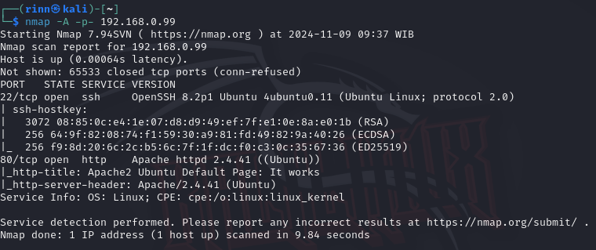

From the results of the Nmap scan on IP 192.168.0.99 using the nmap -A -p-, the following is an explanation of the information displayed:

Port 22 (SSH):

* + Status: Open.
  + Service: ssh with OpenSSH version 8.2p1 running on Ubuntu 4ubuntu0.11.
  + Protocol: Uses SSH protocol version 2.0.

Port 80 (HTTP):

* Status: Open.
* Service: http run by Apache HTTPD version 2.4.41 on Ubuntu.
* Server Banner: Displays the Apache/2.4.41 (Ubuntu) server header.
* HTTP Title: "Apache2 Ubuntu Default Page: It works", indicates that Apache's default page is active, usually indicating that no specific web application is set up on this server yet.
* OS information: Nmap detects the operating system as Linux with CPE (Common Platform Enumeration) cpe:/o:linux:linux_kernel.

Conclusion:

The scan results show that this server is running SSH and HTTP services, with ports open (22 and 80) respectively.

Using the -A option, Nmap successfully identifies the service version, SSH, as well as the target operating system.

6.2. Exploit SSH

The scan results show that this server is running an SSH service on port 22. These steps will lead to performing a brute-force attack to try to gain access to the server via SSH.

* First open Metasploit with the command on the terminal: msfconsole

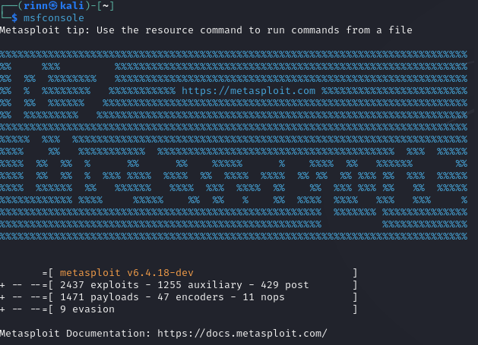

* Metasploit provides a brute-force module for SSH that can be used to try to log in to a server with a commonly used username and password combination.use the ssh_login search command to search for the brute-force module for SSH.

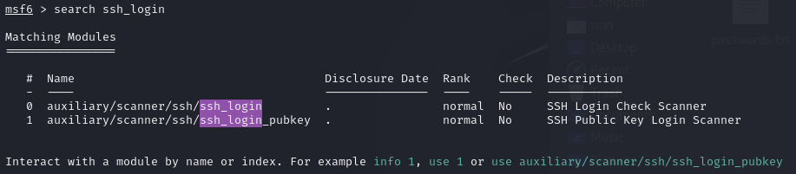

* After that, type the command use 0 or use auxiliary/scanner/ssh/ssh_login. And type show options again to know what the options are before running this module.

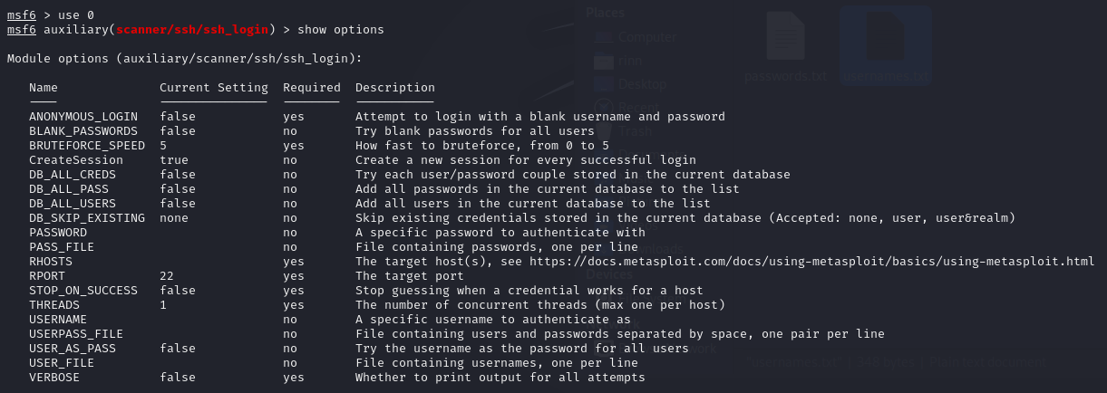

* After that set the target ip with the command: set RHOSTS <target ip>.



* Followed by a set of username and password with the command: set USER_FILE <wordlist> and set PASS_FILE <wordlist> or more specifically with the set USERNAME and set PASSWORD.



Here I made my own wordlist for testing. If you want a more specific worslist, you can use the built-in rockyou from linux or you can search github.

* After that I added some options like set THREADS 10, set STOP_ON_SUCCESS true and set VERBOSE true.

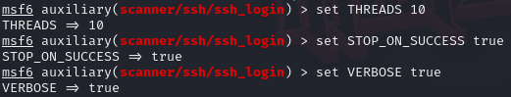

* + set THREADS 10: Uses 10 threads to speed up the attack.
  + set STOP_ON_SUCCESS true: Stops the attack once the correct login combination is found.
  + set VERBOSE true: Enables more detailed output during the attack process to provide more insight into what is happening.
* After that, wait until the metasploit is complete.

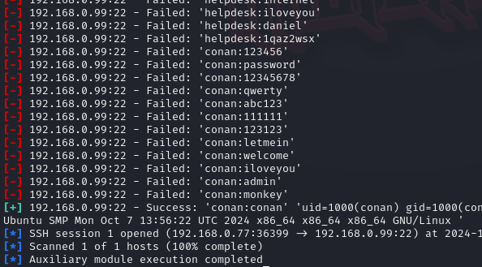

Now here we get the target username and password, namely conan:conan.

* Try to log in to the server with the ssh command username@ip_target.

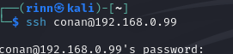

After that, enter the password.

* So a display like this how to check it can use whoami.

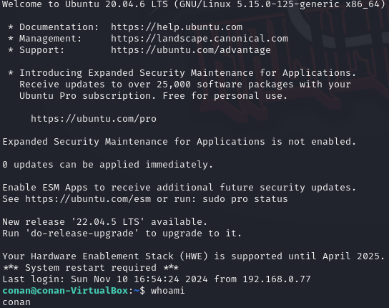

* after successfully logging in to SSH, have full control over the server. can explore system files to look for loopholes, change configurations, add accounts, or install backdoors to maintain access. The attacker can also clear traces of activity by cleaning logs and continuing further exploitation of the server or the wider network.
* On the Ubuntu side, it can monitor suspicious login attempts or brute-force attacks on SSH with the tail command -f /var/log/auth.log.

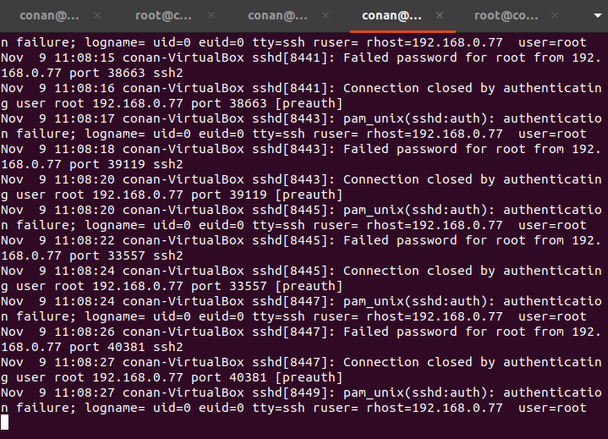

Seen below there is an experiment from ip 192.168.0.77.

* On the ubuntu side, you can also see login/logout activity with the sudo cat /var/log/auth.log command

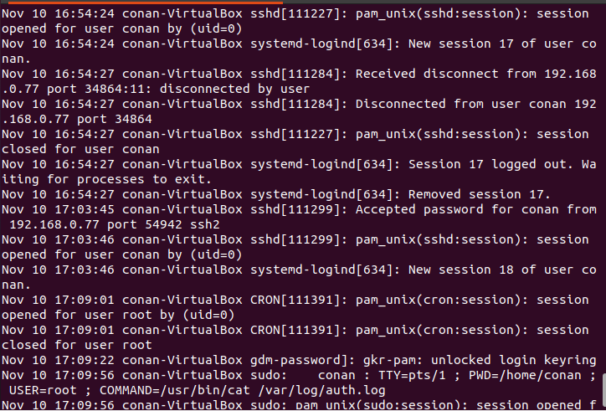

It can be seen that ip 192.168.0.77 successfully logged in.

* Recommendations on how to overcome Brute-Force SSH attacks.
  + Ganti Port Default SSH:

By default, SSH uses port 22. Switching these ports to another port (for example, 2289 or others) can reduce the likelihood of a brute-force attack because attackers typically target standard ports.

* + Enable Fail2Ban to Prevent Brute-Force Attacks:

Fail2Ban is a tool that monitors server logs and blocks IPs that try to log in multiple times in a short period of time. This can help prevent brute-force attacks.

* + Use Strong Passwords

Minimum 12 Characters Length, Diverse Character Combinations, Use Unique Passwords for Each Account.

* + Monitor SSH Logs Regularly:

Use the tail command -f /var/log/auth.log or sudo cat /var/log/auth.log to monitor login activity and detect suspicious login attempts in real-time.

6.3. Exploit webutler v3.2

* The scan results showed that port 80 was open and running HTTP services, which means the server had a website that could be accessed through a browser. After accessing the page, it was discovered that the server was running the Webutler service, which may have its vulnerabilities. To continue the exploit, a search was conducted to find out if there was a known exploit for this service, and the results showed that there was an exploit in exploit-db.com. This exploit can be used to exploit its vulnerability and continue efforts to gain further access to the server.

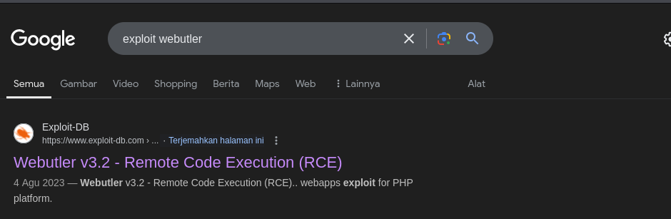

* In the exploit-db documentation we create a file in .phar format. **PHAR** is an archive format that can be executed in PHP. Name the file poc.phar according to the documentation. The contents of the file are <?php echo system("cat /etc/passwd");? > to get information on using Linux.

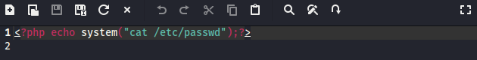

* After that, in the exploit-db document, it is told to log in to the admin account.

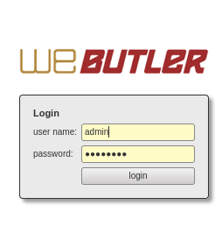

Enter the username and password of the webutler that has been demployed.

* After logging in, click on the media on the left and upload the poc.phar file. If not uploading using the command:



* curl: It is a command-line tool for transferring data using various protocols, including HTTP, FTP, etc.
* -X POST: Indicates that the HTTP request to be sent is the POST method, which is commonly used to send data to the server.
* The URL indicates the version 3.2 Webutler application that is likely to be used to manage files. The parameters in this URL are:
  + upload=newfile: May indicate that a new file will be uploaded.
  + types=file: Indicates the type of file being uploaded is a file.
  + actualfolder=%2F: Specifies the destination directory where the file will be uploaded. %2F is the URL representation of the / character (root directory).
  + filename=poc.phar: The name of the file to be uploaded is poc.phar.
  + overwrite=true: Indicates that if a file with the same name already exists, it will be overwritten.
* -H "Cookie: WEBUTLER=19uemsgtas5klqf7p9bqqgnk9s": An HTTP header that includes a cookie with the name of WEBUTLER and a specific session value. These cookies may be used for authentication or to track a user's session on the app.
* To get the Cookie, we can see it, right-click> select inspect> select storage> select cookies, then you will see the cookie.

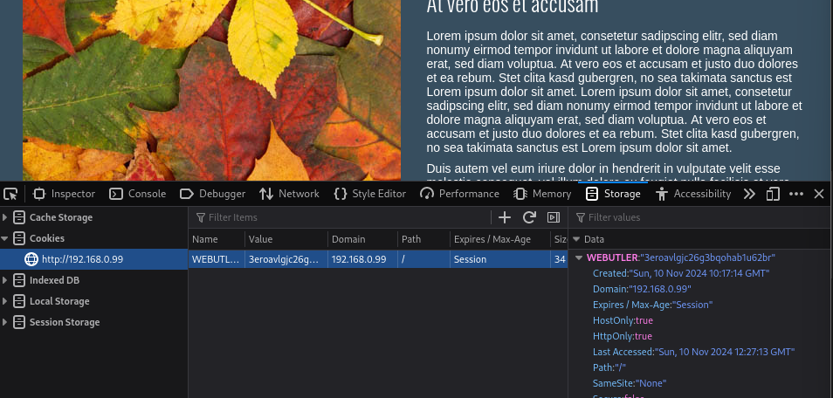

* **-**H "X_FILENAME:poc.phar": A custom HTTP header that sends the name of the uploaded file, i.e. poc.phar. This may be required by a web application to verify or suggest a file name.
* **--**data-binary @/home/rinn/Downloads/poc.phar: Sends the poc.phar file located in the local directory /home/rinn/Downloads/ as binary data (the file itself). This is a way to upload files in a POST request.
* If there is already a writing like this, the file has been uploaded,



* To see the result, type the command in the browser http://192.168.0.99/webutler_v3.2/content/media/file/poc.phar if the /etc/passwd file is in the browser, then the Reverse Code Execution (RCE) is successful.

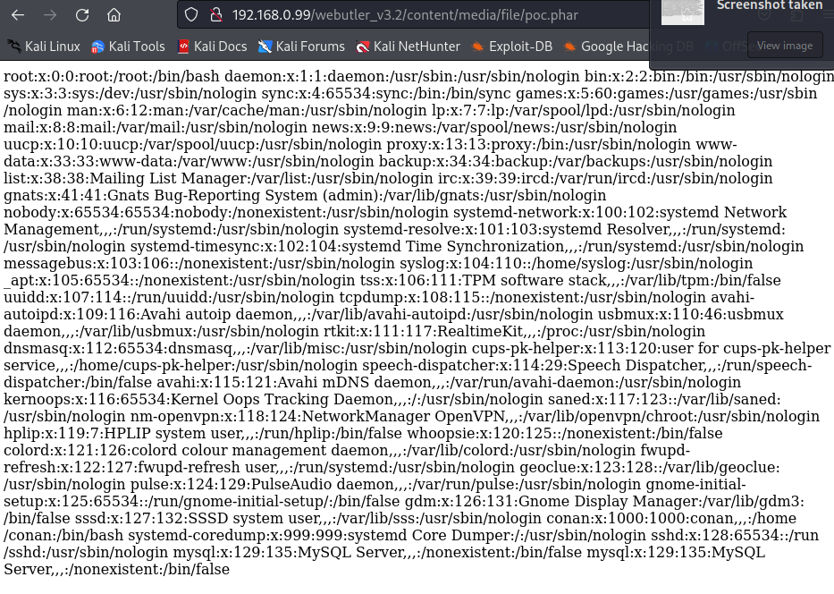

After getting the username we can get **/etc/shadow**: Contains the password hashes for the account in the system. Just upload a file containing <?php echo system("cat /etc/shadow");? > with .phar format, a password hashes will appear. Password hashes can be cracked using the John the Ripper/Hashcat tools, but not all password hashes can be cracked.

* Recommendations on How to Resolve Webutler v3.2 Vulnerability
  + Update Apps: Make sure Webutler is updated to the latest version or has the latest security patches installed.
  + Validate and Limit Upload File Types: Allow only safe file types (e.g. images or PDFs)
  + Monitor and Analyze Server Logs: Regularly check server logs for suspicious activity or attempted exploits.
  + Disable PHP Execution in the Upload Directory: Add a .htaccess configuration in the upload directory to prevent the execution of .php or .phar files.

# **Conclusion**

The project provides an understanding of server settings, from the installation and configuration of IP addresses on Kali Linux and Ubuntu, to the management of services such as SSH, MySQL, Apache, and PHP. Security analysis using Nmap and Metasploit revealed potential vulnerabilities, such as brute-force attacks on SSH and vulnerabilities in Webutler applications. From these findings, efforts to mitigate the impact applied, such as application updates, restriction of upload file types, and monitoring of server logs, improve a practical understanding of the importance of maintaining server security and stability in a production environment.